January 2019

Kaeser at Collision Repair Expo 2019:
Producing high quality and energy efficient compressed air

Visitors to the Collision Repair Expo 2019 that join Kaeser Compressors on stand AC24, will be able to discover the latest in compressed air technology as well learn how they can produce high quality air and operate an energy efficient compressed air system. Kaeser will also be running a seminar on how to achieve high quality compressed air as part of the exhibition’s Free Seminar Series.

With electricity costs remaining high, finding ways to reduce utility bills has never been so important. Compressed air is often considered the fourth utility and as the energy source for most equipment in a collision repair body shop, it is a critical utility for this industry sector. It is also vital because compressed air mixes with the product in paint spraying operations.

The impact of compressed air on workflow, product quality and energy bills however can often be overlooked. This can mean costly rework as a result of poor air quality affecting paint jobs and workflow interruptions due to inadequate air supply. Both will cause real dollar losses in terms of rework costs and inflated energy bills.

Unlike other utilities the end user is in complete control of their compressed air system and a thorough analysis and expert advice can go a long way towards building a reliable and cost effective system.
Make a date with Kaeser at Collision Repair Expo 2019
Kaeser will once again be exhibiting at the biennial Collision Repair Expo being held at the Melbourne Convention and Exhibition Centre from 4 to 6 April 2019. Hosted by the Australian Automotive Aftermarket Association (AAAA), Collision Repair Expo is the nation’s most comprehensive exhibition of body finishing materials, crash repair equipment and tools.
Visitors to stand AC24 will not only be able to discover the latest compressed air technologies ideally suited to the collision repair industry but, they will also be able to get expert advice from Kaeser’s team of compressed air specialists, on how they can ensure their compressed air system is running energy efficiently and producing high quality air.
Kaeser has a number of solutions to meet these requirements and visitors will be able to see a complete Kaeser compressed air system on stand AC24, which will include an SK 22 series rotary screw compressor.
At the heart of every SK series rotary screw compressor is a premium quality screw compressor block with Kaeser Sigma Profile rotors. Superior efficiency is assured with these flow-optimised rotors that are able to achieve power savings of up to 15 percent compared with conventional compressor block rotor profiles.
Free seminar on compressed air quality
The Collision Repair Expo will be running a Free Seminar Series across all 3 days. End users wanting a more in depth understanding about the importance of compressed air quality and how to produce it, are invited to join Kaeser in the Clarendon Room A&B at the expo on Thursday 4 April at 2 pm for a free seminar on this subject. For more information on how to register for this seminar, visit www.collisionrepair.com.au.
For more information from Kaeser visit www.kaeser.com.au or phone 1800 640 611.
-END-
Editors Notes
From 2.2 to 500 kW, Kaeser Compressors manufactures a wide range of compressors and associated auxiliary equipment that meet the varying requirements of a diverse range of industries and applications.

One of the world’s largest manufacturers of rotary screw compressors, Kaeser Compressors is represented globally in over 100 countries through a dedicated network of branches, subsidiary companies and authorised partners.

Kaeser Compressors Australia provides comprehensive sales and service from its 30,000 ft² purpose built factory in Dandenong, Victoria alongside an extensive network of sales and service centres and authorised partners that cover Australia, New Zealand and New Caledonia.

For editorial and advertising enquiries contact:
Press office: +61 3 9791 5999 Fax: +61 3 9791 5733
E-mail: info.australia@kaeser.com

KAESER COMPRESSORS Australia Pty Ltd – 45 Zenith Road, Dandenong South, VIC 3175, Australia
Phone: +61 3 9791 5999 – www.kaeser.com.au – E-mail: info.australia@kaeser.com

File: O-Collision Repair Expo-preview-aus
Approved for publication, copy acknowledgement appreciated
Image:

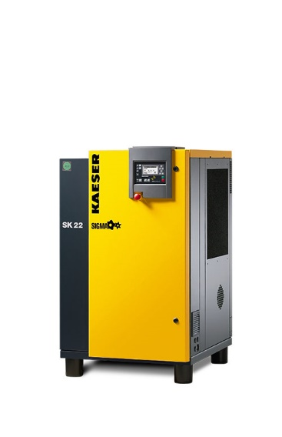
002_Image 1_KAESER SK22.jpg
Caption: Visitors to stand AC24 will be able to see the Kaeser SK22 rotary screw compressor

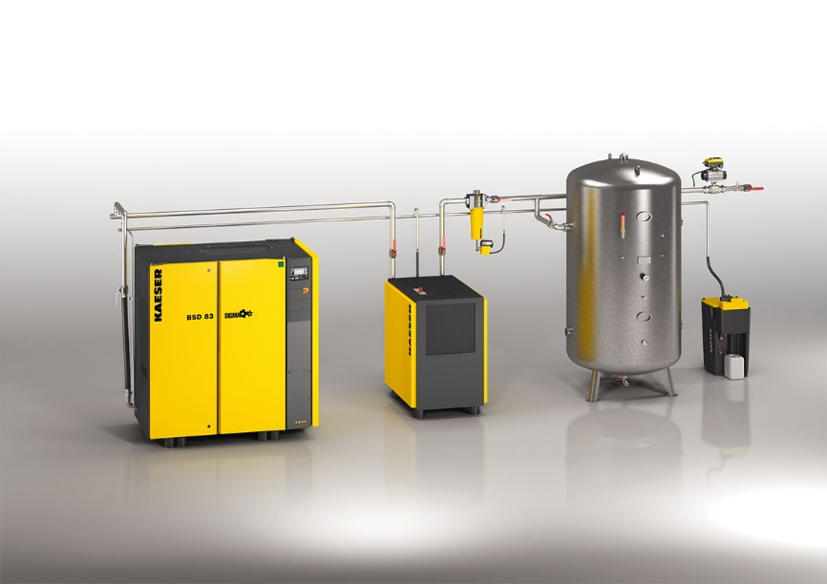
002_Image 2_KAESER compressed air system.jpg
Caption: Visitors to stand AC24 will be able to see a complete Kaeser compressed air system

((Kaeser photo – free for publication))

