January 2022

Kaeser launches DN 37 C XL booster:
Designed for high air demand up to 25 bar

Kaeser Compressors has just announced the launch of the DN 37 C XL booster. Part of the powerful, energy efficient and turnkey DN C series of boosters, this new model has been designed for applications such as PET bottle production, process air applications and nitrogen generation, that require high air demand up to 25 bar.

Powerful, compact and quiet, DN C boosters from Kaeser Compressors deliver uncompromising performance, dependability and energy efficiency. These innovative complete systems come into their own when, due to technical reasons, specific points in a production process require compressed air at a higher pressure than that supplied by the main compressed air network. They can therefore often be found in PET bottle production, process air applications, nitrogen compression and the provision of high pressure for testing facilities.
The recently launched DN 37 C XL model, has been specially designed for high air demand. Kaeser’s largest compressor block, the DN 37 C XL, is the perfect choice for applications with high air demand up to 25 bar, delivering the highest possible flow rate available for this product series.

Energy-efficiency as standard
As you would expect from Kaeser, energy-efficiency comes as standard with these boosters;
Premium Efficiency (IE3) drive motors, equipped as standard, contribute to energy-efficient performance, as does the generously dimensioned axial fan, which also ensures reliable temperature control.
The DN C series boosters also feature separate cooling air flows for the compressor block, drive motor and control cabinet, which are drawn in through openings in the right-hand side of the enclosure. Once they have been used for cooling, the separate air flows are combined and then discharged upwards through the exhaust air outlet in the top of the enclosure.
This clever design reliably prevents cool inlet air from mixing with warm exhaust air – for enhanced efficiency. Thermal overload is therefore kept to a minimum and a separate, energy-consuming cooling system for idling is only necessary under extreme conditions.

Turnkey ‘all-in-one’ solutions
DN C series boosters are delivered as complete turnkey systems, precisely matched to the upstream compressor. Thanks to the Sigma Control 2 controller, they are ready for connection and self-monitoring. This is a huge advantage for keeping installation time and costs to a minimum. Kaeser Compressors is the first manufacturer in the booster sector to offer such a user-friendly complete solution, that is all neatly contained within a single compact enclosure.

Service-friendly
All maintenance-relevant components, such as cylinders and venting valves, filters, condensate separators, oil drain and filler openings are easily accessible thanks to large maintenance doors. Time saving features such as these streamline and accelerate maintenance and service work, which translates into lower operating costs and increased availability.

Industries 4.0-ready
These new booster systems are furthermore perfectly matched for seamless networking with their “suppliers” – making them fully compatible with Industrie 4.0 environments.

The DN 37 C XL booster from Kaeser Compressors is available air-cooled or water-cooled, and produces flow rates from 11.54 to 18.9 m³/min. Initial pressure 7.5 to 13 bar, and final pressure 25 bar. For more information visit au.kaeser.com or phone 1800 640 611.
-END- Free for publication, copy appreciated
Editors Notes
From 0.18 to 515 kW, Kaeser Compressors manufactures a wide range of compressors and associated auxiliary equipment that meet the varying requirements of a diverse range of industries and applications.
One of the world’s largest manufacturers of compressors, blowers and compressed air systems, Kaeser Compressors is represented throughout the world by a comprehensive network of branches, subsidiaries and authorised distribution partners in over 140 countries.

Kaeser Compressors Australia provides comprehensive sales and service from its purpose built factory in Dandenong, Victoria alongside an extensive network of sales and service centres and authorised partners that cover Australia and New Caledonia.

For editorial and advertising enquiries contact: Beth Wood, Marketing Manager
Press office: +61 3 9791 5999 Fax: +61 3 9791 5733
E-mail: beth.wood@kaeser.com

KAESER COMPRESSORS Australia Pty Ltd
45 Zenith Road, Dandenong, VIC 3175, Australia
Phone: +61 3 9791 5999 Email: info.australia@kaeser.com
au.kaeser.com
File: B-DN37CXL-aus
Approved for publication, copy acknowledgement appreciated

Images:
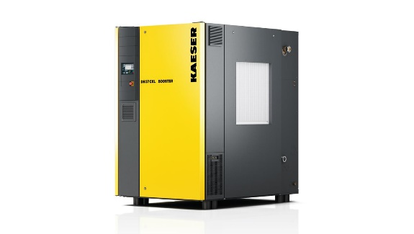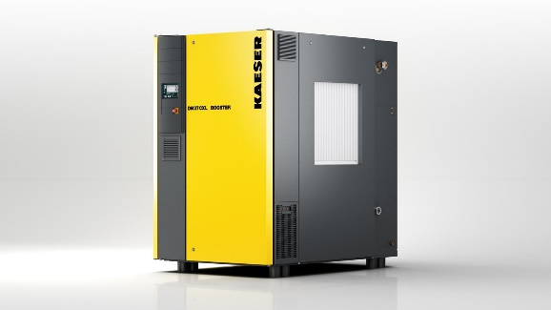
Caption: The new DN 37 C XL turnkey booster has been specially designed for high air demand up to a maximum of 25 bar
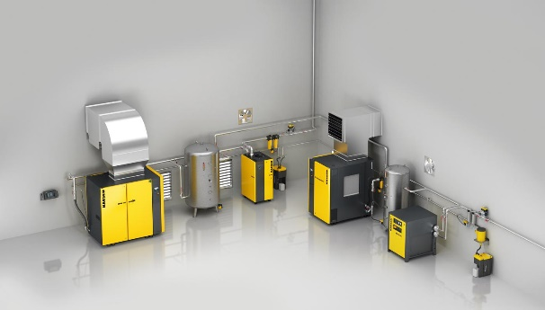
Caption: An optimally adapted, holistic solution - a complete Kaeser compressed air system including boosters, meeting low and high pressure demands
((Kaeser photo – free for publication))

