July 2022

Pure efficiency
Kaeser expands rotary screw blower range

Kaeser recently expanded its FBS series of rotary screw blowers with the inclusion of the FBS 720 models. This represents the next milestone in the development of oil-free compression blower technology, designed especially with water industry applications in mind.

With a flow rate of 18 to 72 m³/min and pressure differentials from 0.3 to 1.1 bar, as well as a selection of motors ranging from 45 to 110 kW, the innovative FBS series continues the success story of its smaller sibling, the EBS series, whilst setting new standards in terms of energy efficiency, space-saving design and automation.

The SFC version is equipped with a frequency converter and a synchronous reluctance motor – a slip-free design that combines all the advantages of high-efficiency permanent-magnet motors with those of robust, service-friendly asynchronous motors. Thanks to variable speed control, the flow rate can be adjusted as required and a control range of 1:4 is achieved, allowing exceptionally dynamic operation.

The STC version is now equipped with an energy-saving IE4 Super Premium Efficiency motor, which reduces energy consumption and therefore costs, making the STC version more efficient than ever before.

On both versions, power transmission from the motor to the airend takes place via loss-free and maintenance-free gearing, which results in an improvement of up to 7% in specific package input power as compared to the previous model. The complete machine achieves an efficiency range that represents the pinnacle of performance for this particular segment. In order to ensure that the specified performance figures are translated into reality, Kaeser guarantees performance in accordance with the strict tolerances of the ISO 1217-C/E standard.

Furthermore, efficiency remains constant across the entire control range and flow rate is virtually unaffected by pressure fluctuations. This allows the blowers to be precisely regulated and adjusted at all times via the master control system, achieving even greater energy savings and ensuring seamless integration with other control technologies.

Despite the compact dimensions of the FBS, Kaeser has succeeded in dispensing with the requirement for maintenance access from one side, thereby permitting side-by-side installation. This results in considerable space savings, particularly when operating multiple blower systems.

FBS rotary screw blowers are delivered ready for immediate connection, including controller and frequency converter or star-delta starter. All units are CE and EMC-certified, thereby minimising the planning, construction, certification, documentation and commissioning costs for planners, operators and plant manufacturers. Last but not least, highly effective sound and pulsation damping ensure exceptionally quiet operation.

The FBS series models are available to order from September 2022. For more information visit au.kaeser.com or phone 1800 640 611.
-END- Free for publication, copy appreciated
Editors Notes
From 0.18 to 515 kW, Kaeser Compressors manufactures a wide range of compressors and associated auxiliary equipment that meet the varying requirements of a diverse range of industries and applications.
One of the world’s largest manufacturers of compressors, blowers and compressed air systems, Kaeser Compressors is represented throughout the world by a comprehensive network of branches, subsidiaries and authorised distribution partners in over 140 countries.

Kaeser Compressors Australia provides comprehensive sales and service from its purpose built factory in Dandenong, Victoria alongside an extensive network of sales and service centres and authorised partners that cover Australia and New Caledonia.

For editorial and advertising enquiries contact:
Press office: +61 3 9791 5999 E-mail: marketing.au@kaeser.com

KAESER COMPRESSORS Australia Pty Ltd
45 Zenith Road, Dandenong, VIC 3175, Australia
Phone: +61 3 9791 5999 Email: info.australia@kaeser.com
au.kaeser.com
File: H-FBS-720-aus
Approved for publication, copy acknowledgement appreciated

Images:
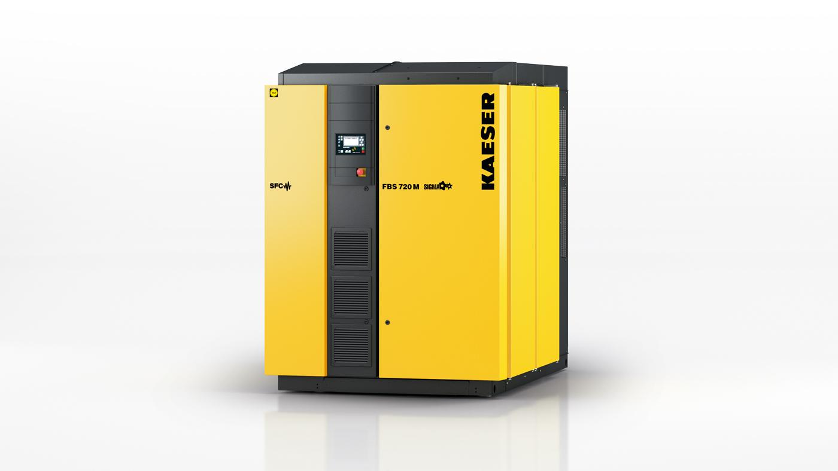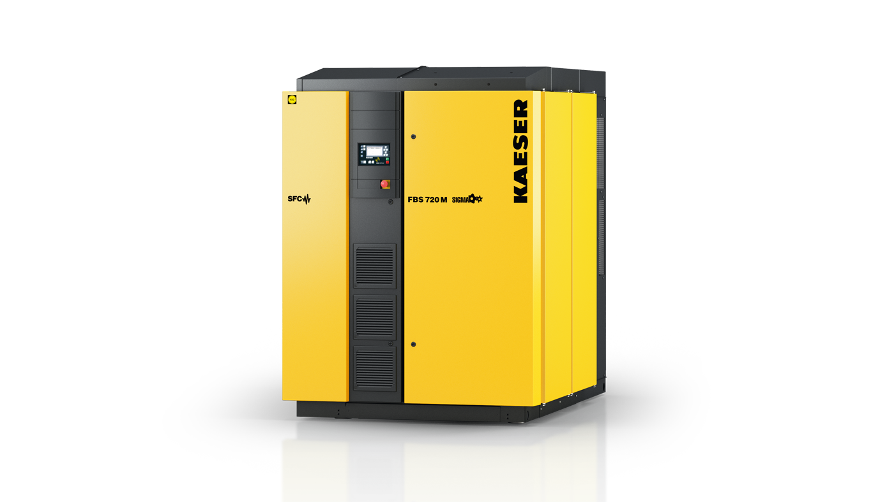
Caption: The FBS series rotary screw blowers from Kaeser Compressors are true standouts thanks to their high levels of efficiency and compact design.

((Kaeser photo – free for publication))

