February 2019

Kaeser at Hannover Fair 2019: Smart and efficient compressed air solutions for every need

Proudly celebrating its centenary in 2019, Kaeser is set to display the entire scope of its compressed air expertise at Hannover Fair, including numerous innovations that are a perfect match for the exhibitions 2019 lead theme of Integrated Industry. Visitors can also learn more about the growing importance of Industrie 4.0

Highly efficient compressors, effective compressed air treatment systems, smart engineering and intelligent services are just a few of the highlights that reveal the modern face of needs-based compressed air production in combination with good planning.

Kaeser is offering a glimpse of the future. Smart engineering station simulations make it possible to see a fully operational compressed air station before it has even been built. Moreover, the new Sigma Smart Air shows how maintenance is carried out in the age of Industrie 4.0. With the comprehensive service package, Sigma Smart Air offers a combination of remote diagnosis and data-based, predictive maintenance that saves the user both time and money, while ensuring the availability of the compressed air supply. The basis of these forward-looking concepts is the Sigma Air Manager 4.0 in combination with the Sigma Network. The powerful, closed network and intelligent controller are perfectly coordinated cornerstones of Kaeser's Industrie 4.0 package.

Operating efficiency is of key importance at Kaeser on every level, together with a responsible approach to resource conservation. Therefore, all variable-speed rotary screw compressors are being systematically equipped with a synchronous reluctance motor, which boasts considerably lower losses – and, in turn, greater efficiency - in the crucial partial-load range compared to asynchronous motors. Following in the footsteps of the ASD series, the CSD/CSDX series is the next to feature efficiency improvements of up to 10 percent, with flow rates ranging from 1.1 to 17.5 m³/min., paving the way for minimal energy costs.

If oil-free compressed generation air is required, FSG series rotary screw compressors provide the perfect solution in combination with i.HOC rotation dryers: not only highly efficient and cost-effective, they also achieve stable pressure dew points to minus 30 degrees Celsius.

With a drive power of 7 to 45 kW, Kaeser's innovative boosters are the powerhouses of choice when higher pressure compressed air is called for (up to 45 bar). Compact and space-saving, with low-noise, vibration-free performance, they are ideal all-in-one booster solutions and are also available as variable-speed versions.

The needs of tradies and workshops are also well catered for by Kaeser, with a compressed air solution for every application. The new i.Comp reciprocating compressors are robust, powerful, compact, maintenance friendly, efficient – the list goes on. The centrepiece is the new drive concept, which offers a host of advantages. Every reciprocating compressor model delivers exactly the output required and can be infinitely adjusted to suit actual compressed air demand. Manufactured to the very highest industrial quality standards for which Kaeser is world-renowned, i.Comp models are available as portable models and as space-saving i.Comp tower compact stations – a completely new compressed air supply concept that was specially developed for workshops.

To learn more visit Kaeser Compressors in Hall 26, Stand C51 or either of the two outdoor stands in front of Hall 26. For more information from Kaeser visit www.kaeser.com.au or phone 1800 640 611.
-END-
Editors Notes
From 2.2 to 500 kW, Kaeser Compressors manufactures a wide range of compressors and associated auxiliary equipment that meet the varying requirements of a diverse range of industries and applications.

One of the world’s largest manufacturers of rotary screw compressors, Kaeser Compressors is represented globally in over 100 countries through a dedicated network of branches, subsidiary companies and authorised partners.

Kaeser Compressors Australia provides comprehensive sales and service from its 30,000 ft² purpose built factory in Dandenong, Victoria alongside an extensive network of sales and service centres and authorised partners that cover Australia, New Zealand and New Caledonia.

For editorial and advertising enquiries contact:
Press office: +61 3 9791 5999 Fax: +61 3 9791 5733
E-mail: info.australia@kaeser.com

KAESER COMPRESSORS Australia Pty Ltd – 45 Zenith Road, Dandenong South, VIC 3175, Australia
Phone: +61 3 9791 5999 – www.kaeser.com.au – E-mail: info.australia@kaeser.com

File: O-HMI 2019-preview-aus
Approved for publication, copy acknowledgement appreciated
Image:

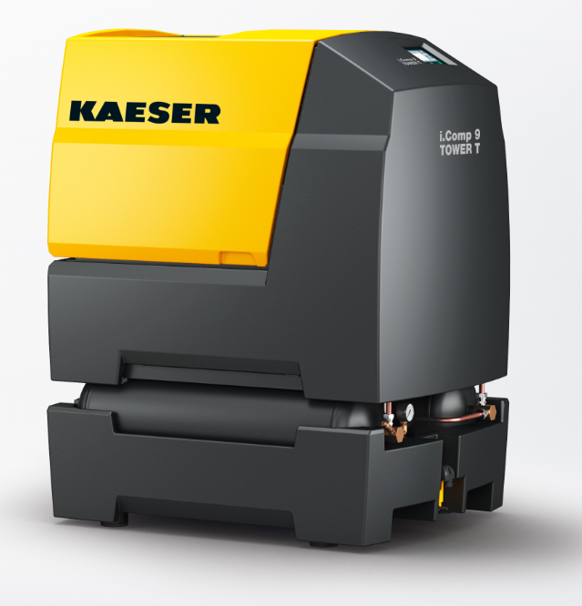
004_Image 1_KAESER iCOmp.jpg
Caption: The new i.Comp reciprocating compressors are robust, powerful, compact, maintenance friendly, efficient

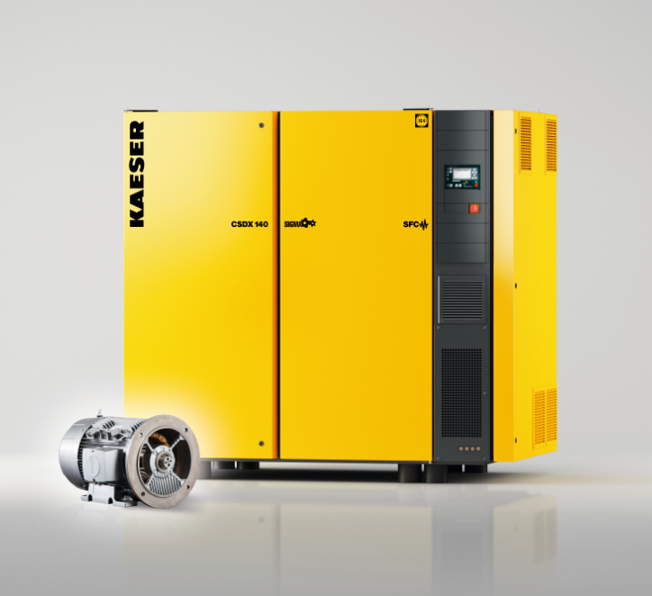
004_Image 2_KAESER CSD.jpg
Caption: Optimal configuration for maximum efficiency: the variable-speed versions of the CSD rotary screw compressors feature a highly efficient synchronous reluctance drive system.

((Kaeser photo – free for publication))

