March 2021
Complete and compact turnkey booster systems:
Kaeser launches its latest generation of boosters

Kaeser Compressors has just announced the launch of its latest generation boosters that cover the 7.5 to 22 kW drive power range. The new CN C series booster models are energy efficient, complete and compact turnkey systems that are ideal wherever high pressure compressed air is required such as PET bottle production, process air applications and nitrogen generation.

Powerful, compact and quiet, the CN C series of boosters from Kaeser Compressors make no compromise when it comes to performance, dependability and energy efficiency. These innovative complete systems come into play when, for technical reasons, specific points in a production process require a pressure higher than the network pressure. Wholly redesigned with a clever new layout, the CN C series boosters quite literally have everything you need:

The new CN C series boosters are completely unique. All application-relevant components are provided and configured ex-works for delivery of a complete turnkey system that is ready for immediate operation. With a footprint of only 1.9 m² they are also compact keeping the space requirement to a minimum. And, encompassed within a sound enclosure keeps sound pressure levels down to as little as 71 dB(A).

These next generation boosters are more energy efficient than ever before. A premium efficiency (IE3) drive motor is fitted as standard. This contributes to cost-effective energy usage, as does the generously dimensioned radial fan, which also serves to ensure reliable temperature control.
CN C series boosters feature separate cooling air flows for the compressor block, drive motor and control cabinet, which are taken in through openings in the right-hand side of the enclosure. Once they have been used for cooling, the streams are combined, then blown up and out through the exhaust air outlet in the top of the enclosure. This clever design reliably prevents cool inlet air from mixing with warm exhaust air – for enhanced efficiency.

As you would expect from a Kaeser machine, the CN C series boosters are service friendly. All maintenance-relevant components, such as cylinders and venting valves, filters, condensate separators and oil drainage/filler openings are easily accessible thanks to large maintenance doors. The removable panel on the cooler side allows simple belt changes and provides easy access to the cooler.

For efficient control and monitoring of the compressor operation, the CN C series boosters come with an integrated Sigma Control 2 controller. This automatically monitors all key values: initial and final pressure, block discharge temperature of the individual cylinders, drive motor winding temperature, oil pressure/level and compressed air discharge temperature.
A further key advantage of these new booster systems is that they are perfectly matched for seamless networking with their “suppliers” – making them fully compatible with Industrie 4.0 environments. This means that CN C series boosters are the ideal solution for such operations as PET bottle production, process air applications, nitrogen generation and the provision of high pressure for testing facilities.

The CN C series of boosters from Kaeser Compressors are available with drive powers of 7.5 to 22 kW, and produce flow rates from 0.8 to 8.0 m³/min. Initial pressure 3 to 13 bar, and final pressures 10 to 45 bar. For more information visit au.kaeser.com or phone 1800 640 611.
-END- Free for publication, copy appreciated
Editors Notes
From 0.18 to 515 kW, Kaeser Compressors manufactures a wide range of compressors and associated auxiliary equipment that meet the varying requirements of a diverse range of industries and applications.

One of the world’s largest manufacturers of rotary screw compressors, Kaeser Compressors is represented globally in over 100 countries through a dedicated network of branches, subsidiary companies and authorised partners.

Kaeser Compressors Australia provides comprehensive sales and service from its 30,000 ft² purpose built factory in Dandenong, Victoria alongside an extensive network of sales and service centres and authorised partners that cover Australia and New Caledonia.

For editorial and advertising enquiries contact: Beth Wood, Marketing Manager
Press office: +61 3 9791 5999 Fax: +61 3 9791 5733
E-mail: beth.wood@kaeser.com

KAESER COMPRESSORS Australia Pty Ltd
45 Zenith Road, Dandenong, VIC 3175, Australia
Phone: +61 3 9791 5999 Email: info.australia@kaeser.com
au.kaeser.com
File: B-CNC-booster-aus
Approved for publication, copy acknowledgement appreciated
Images:
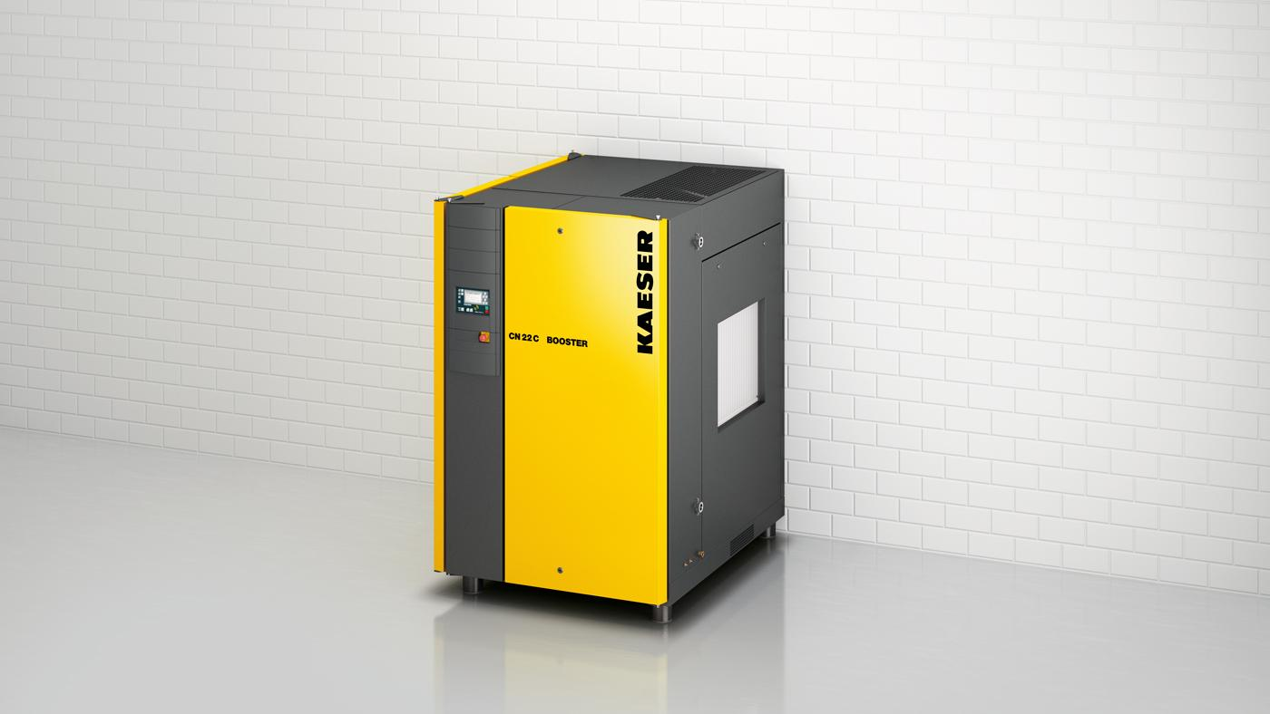
Caption: Kaeser launches the turnkey CN C series of booster systems

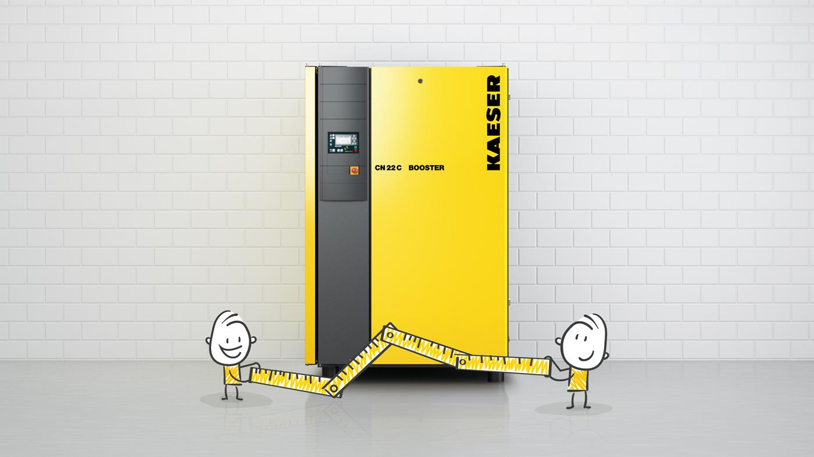
Caption: With a footprint of only 1.9 m² these compact booster systems keep the space requirement to a minimum.

Kaeser photo(s) – free for publication, credits appreciated.

