April 2022
Along for the ride:
Delivering quality compressed air to prestige vehicle repairer for over two decades
Maintaining its position as one of the best luxury vehicle repairers in Australia has meant a long term commitment at Charlie Battisti & Co. to continuously investing in the latest and most efficient technology. Kaeser Compressors has been on hand for over two decades now, ensuring their team of highly trained refinishing, repair and painting experts have access to a reliable and efficient supply of quality compressed air on demand.

When it comes to repairing prestige vehicles, Charlie Battisti & Co. has over 30 years of experience under its belt. Melbourne’s finest smash repairers, Charlie Battisti is one of only a handful of body shops Australia wide, that is a Porsche Certified Collision Centre, an Accredited BMW Body Shop and Mercedes Benz dealer recommended.

Accident repairs, detailing and windscreen replacement are just a few of the services Charlie Battisti offers to its customers. However, regardless of the job at hand the focus is always the same - to ensure that the customer is 100 percent satisfied with all repairs undertaken and to maintain the vehicle's original build quality, strength and integrity.

To meet these goals Charlie Battisti invested some years ago in a state-of-the-art and purpose built vehicle repair facility. Built with vehicle manufacturers specifications in mind, this modern facility in Nunawading houses all the latest approved repair, chassis alignment and measuring systems to ensure that all repairs meet the most exacting industry standards. To maintain its position as one of the best luxury vehicle repairers in Australia, the company continuously invests in the latest technology - not least the compressed air system.

Quality craftsmanship requires quality compressed air
Compressed air is an essential utility at the facility that is used extensively. From powering the air tools - such as the sanders and polishers - to providing air to the dedicated paint refinish facility, the highly trained refinishing, repair and painting experts at Charlie Battisti require a dependable supply of high quality compressed air.

To meet these requirements back when Charlie Battisti first moved into the new facility, they opted for a Kaeser AS 31 series rotary screw compressor. Renowned for quality, reliability and efficiency, Kaeser was the ideal choice. After 15 years of reliable service it was time to once again upgrade the compressed air system and invest in the latest and most efficient compressed air technology available. To reliably and efficiently meet the compressed air requirements of the facility, Kaeser recommended and subsequently installed an ASK 28 rotary screw compressor complete with air treatment.

True class leaders when it comes to performance, the ASK series of rotary screw compressors deliver more compressed air for less energy. At the heart of every ASK system lies a premium quality screw compressor block featuring the energy saving Sigma Profile rotors. Kaeser airends are equipped with flow-optimised rotors, which contribute significantly to the overall system’s class-leading specific package input power. Efficiency is further enhanced with the inclusion of a Premium Efficiency IE3 drive motor, which complies with and exceeds prevailing Australian GEMS regulations for 3 phase electric motors. Furthermore, the internal Sigma Control 2 controller ensures efficient compressor control and monitoring at all times.

The ASK series also combine ease of use and maintenance-friendliness with exceptional versatility and environmentally responsible design. In addition, the soundproofed housing keeps operational noise to a minimum. Normal conversation can take place right next to the compressor, making the ASK series ideal at point of use.

Over two decades of reliable service
Seven years on and the ASK 28 continues to reliably and efficiently meet Charlie Battisti’s compressed air requirements, with the AS 31 remaining onsite as the back-up, when for example the ASK 28 is being serviced.

Shane Perry, Paint Shop Manager of Charlie Battisti said: ‘As a prestige vehicle repairer it’s always been important for us to invest in high quality equipment and Kaeser certainly ticks that box. We’ve been more than happy with the performance of the Kaeser compressors over the years. Moreover, the after sales and service support we’ve received from Kaeser over two decades now has been great.’

The standard ASK series of rotary screw compressors from Kaeser Compressors are available with drive powers of 15 to 22 kW, and produce flow rates from 1.93 to 4.45 m³/min, pressure 6 to 13 bar. For more information visit au.kaeser.com or phone 1800 640 611.
-END- Free for publication, copy appreciated
Editors Notes
From 0.18 to 515 kW, Kaeser Compressors manufactures a wide range of compressors and associated auxiliary equipment that meet the varying requirements of a diverse range of industries and applications.
One of the world’s largest manufacturers of compressors, blowers and compressed air systems, Kaeser Compressors is represented throughout the world by a comprehensive network of branches, subsidiaries and authorised distribution partners in over 140 countries.

Kaeser Compressors Australia provides comprehensive sales and service from its purpose built factory in Dandenong, Victoria alongside an extensive network of sales and service centres and authorised partners that cover Australia and New Caledonia.

For editorial and advertising enquiries contact: Beth Wood, Marketing Manager
Press office: +61 3 9791 5999 E-mail: beth.wood@kaeser.com

KAESER COMPRESSORS Australia Pty Ltd
45 Zenith Road, Dandenong, VIC 3175, Australia
Phone: +61 3 9791 5999 Email: info.australia@kaeser.com
au.kaeser.com
File: Q-Charlie-Battisti-case-study-aus
Approved for publication, copy acknowledgement appreciated
Images:
Contact our press office (beth.wood@kaeser.com) to request high res versions of the images found below.

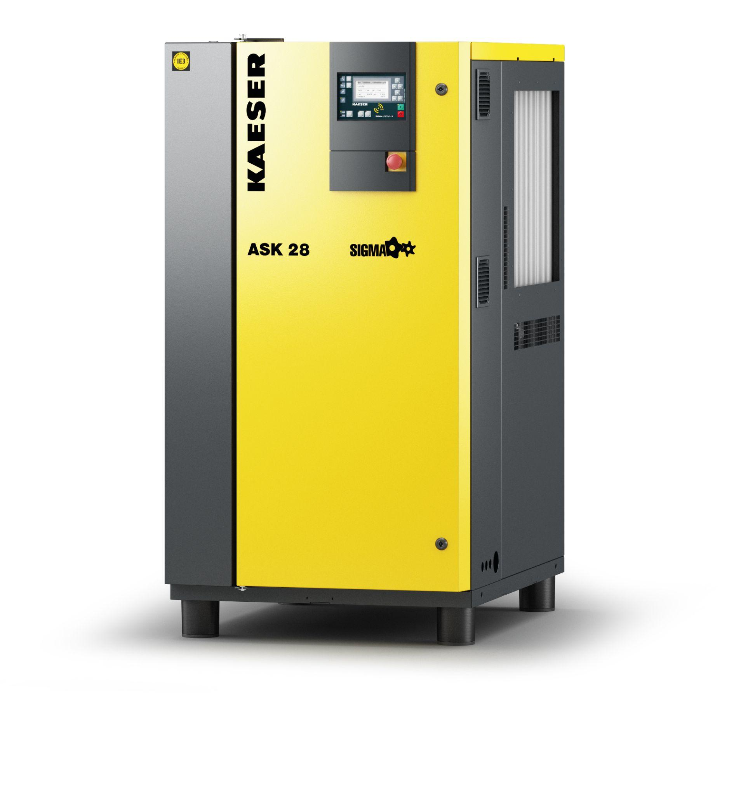
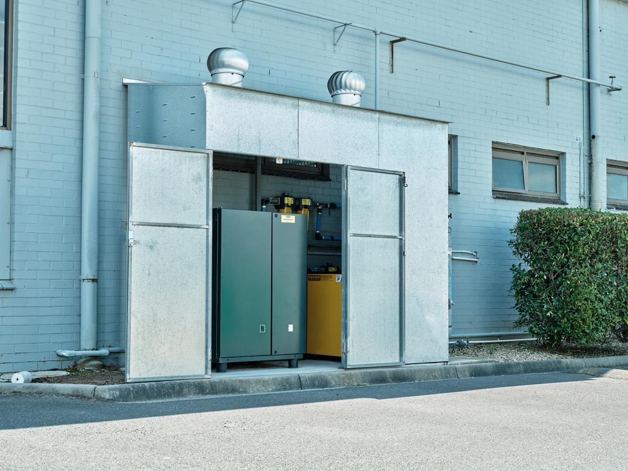
Caption: Seven years on and the ASK 28 continues to reliably and efficiently meet Charlie Battisti’s compressed air requirements
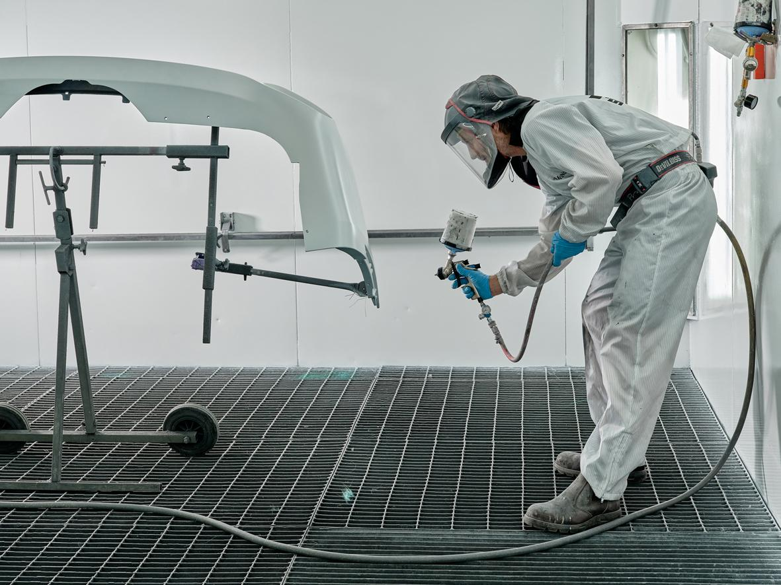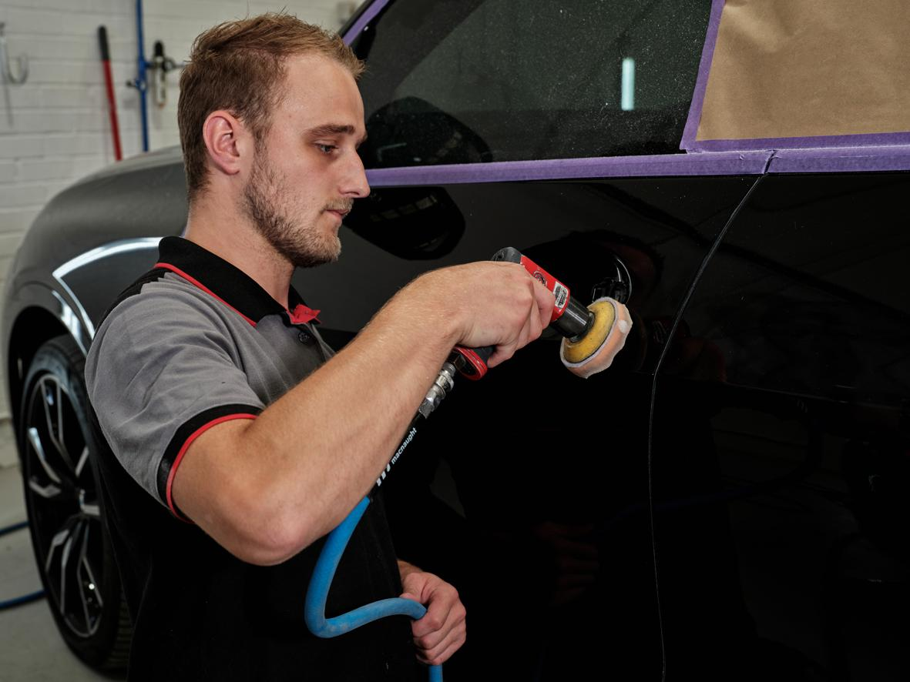
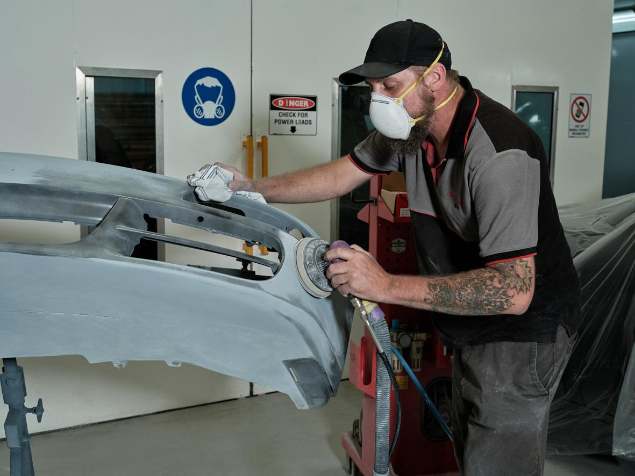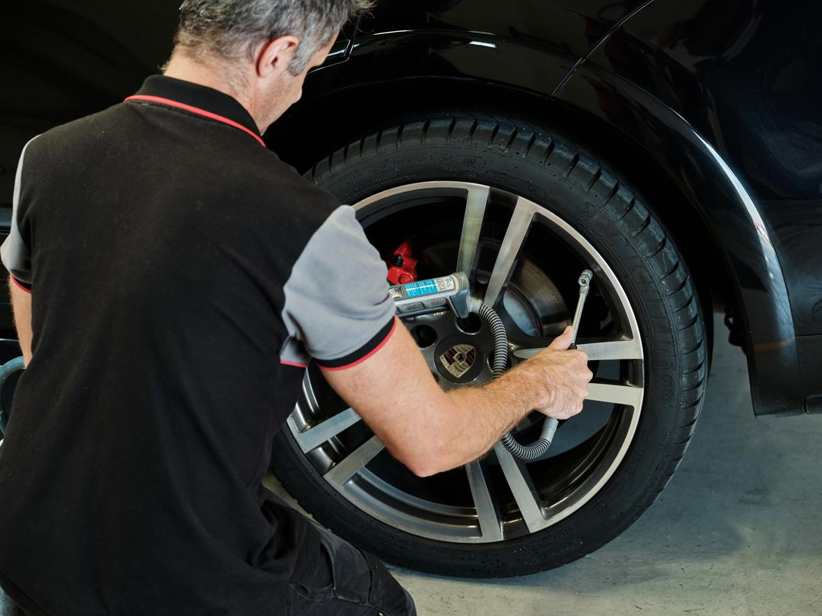
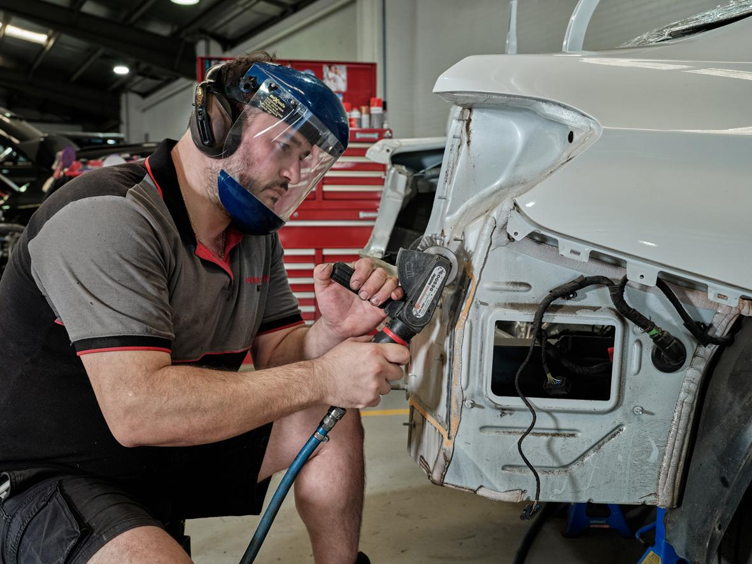
Caption: Compressed air is an essential utility at Charlie Battisti. It is used extensively, from powering the air tools - such as the sanders and polishers - to providing air to the dedicated paint refinish facility.

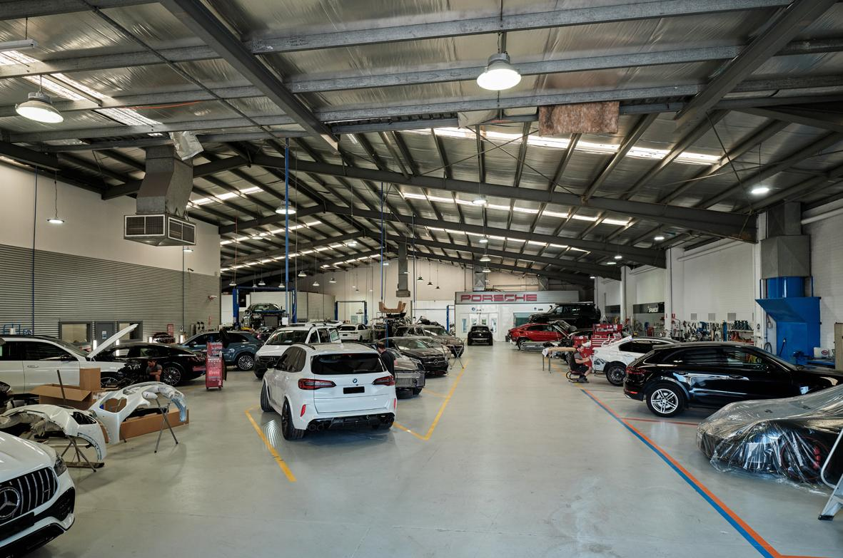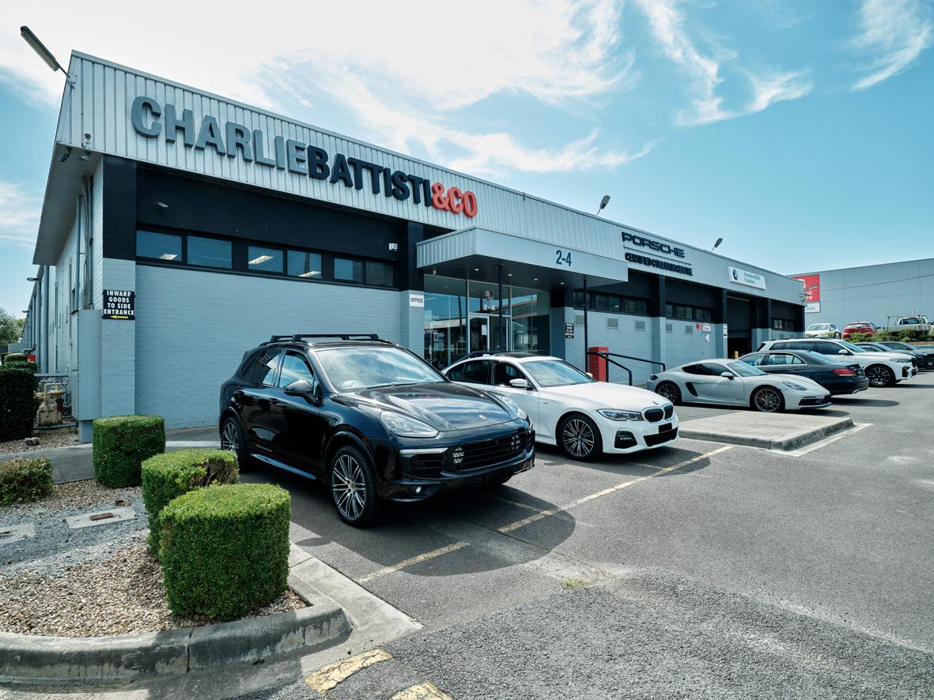
Caption: Maintaining its position as one of the best luxury vehicle repairers in Australia has meant a long term commitment at Charlie Battisti & Co. to continuously investing in the latest and most efficient technology.

Kaeser photo(s) – free for publication, credits appreciated.

