May 2020
Choosing the right blower for low pressure applications

A variety of machines are available for generating compressed air: rotary lobe blowers, rotary screw blowers and turbo blowers, to name but a few. With a wealth of options on offer, operators looking to purchase reliable and long-lasting equipment will find it pays dividends to conduct an extensive demand analysis before making any investment, so as to ensure that they are selecting the machine best suited to their requirements. Here Kaeser Compressors shares an extract from their latest whitepaper - ‘Choosing the right blower’

Operating companies have a broad spectrum of blowers from which to choose. The most common types of machine are rotary lobe blowers, rotary screw blowers and turbo blowers, which tend to generate differential pressures between 0.4 and 1.0 bar at flow rates up to 250 m³/min.

Technical differences
When it comes to generating oil-free compressed air in the low pressure range, there are basically two different types of technology available: positive displacement compressors, which include both twin-shaft rotary lobe blowers and rotary screw compressors, and dynamic compressors, which include turbo blowers.
Viewed from their cross-section, the male and female rotors on a rotary lobe blower appear virtually identical; both feature three lobes and run longitudinally in a straight line. There is no pressure build-up within the blower block itself. Rather, it builds up in the process lines on account of the air molecules constantly pushing against the prevailing resistance generated by the blower. Robust and inexpensive to maintain, rotary lobe machines are recommended where differential pressures between 0.2 and 0.5 bar are required. Depending on the size of the machine, they can reach blower speeds of 2000 – 6000 rpm and a control range up to 1:3. When combined with an integrated frequency converter, they achieve an isentropic efficiency of between 45 and 60 percent.
Since the development of rotary screw blowers, rotary lobe blowers tend only to be used in the water treatment industry when low pressures and short running periods are called for – as with filter backwashing, for example, or for applications featuring strong pressure fluctuations and long idling periods, such as the pneumatic conveyance of bulk materials.
Rotary screw blowers are equipped with two screw-shaped rotors, which interlock together. Compression takes place inside the airend; as the rotors turn, the volume of the intake air trapped in the grooves is constantly reduced. Rotary screw blowers are high-efficiency machines, ideal for differential pressures ranging from 0.4 to 1.1 bar and capable of achieving a control range of 1:4. When combined with an integrated frequency converter, they achieve an isentropic efficiency of between 60 and 78 percent, which remains stable even at constant pressure and a varying flow rate. The latest models are available with flow rates ranging from 5 to 165 m³/min and, depending on size, can achieve blower speeds of 3000 – 12,000 strokes/min. In the water treatment industry, these blowers are ideally suited to the aeration process, on account of the need for long operating hours, a broad control range and a constant efficiency curve for the flow rate.
Turbo blowers are usually deployed in water treatment applications as single-stage compressors. Here, pressure build-up takes place through an increase in flow speed at the turbo’s impeller, which is subsequently converted into pressure in the diffusor.
The classic turbo blower design features a three-phase, asynchronous motor producing impeller speeds of 20,000 – 30,000 rpm via a transmission. Flow rate and pressure are controlled via an adjustable guide vane, which makes this type of machine on the whole somewhat maintenance-intensive. However, the new generation of turbo blowers, equipped with a high-speed permanent magnet synchronous motor (PMSM) and a frequency converter, are capable of reaching the necessary speeds without need of a transmission. Magnetic-bearing turbo blowers achieve an isentropic efficiency of between 60 and 78 percent. In contrast to positive displacement compressors, a turbo blower’s peak efficiency is reached within a narrow range and is far more dependent on a particular pressure and flow rate.
A turbo blower’s flow rate varies more starkly with changes in pressure; an initial control range of 1:3 can easily drop to below 1:2. This must be highlighted during the planning phase, in order to avoid any gaps arising in the control range later on.
Turbo blowers are recommended for aeration applications in the water technology sector, where the flow rates associated with rotary screw blowers are insufficient when the unit size of the machine is brought into consideration.

Decision guide
When deciding whether turbo blowers, rotary screw blowers, or even a combination of both are best suited to a particular project, it may be useful to consider the following questions:
The first criteria to be considered are calculations for the required flow rate, their control range, the required pressure and the potential pressure fluctuations.
The second set of decision criteria is concerned with the prevailing operating conditions, i.e. questions concerning the amount of space available and whether the equipment is to be installed indoors or outdoors. Also, the prevailing maximum / minimum ambient temperatures and inlet air temperatures, relative humidity and the existence of any contaminants (particulates, pollen, gas, etc.) in the air. The geographical elevation must also be considered. Reduced ambient / inlet air pressure has an influence on the performance of the machine.
The third set of decision criteria concerns a comparison of both machine and process performance data.

Should different types of technology be combined?
It is not altogether infrequent to find that a combination of both types of technology provides the best solution. Particularly in the water treatment industry, where the broadest possible flow rate control range must be covered in the lower ranges, it is increasingly common that air stations operate with a mixture of turbo and rotary screw blowers. Based on the specific output (kW per m³/min), a combination of rotary screw blower and turbo blower is the most efficient solution for covering the flow rate with the highest frequency. A second rotary screw blower can be a cost-effective choice as a redundancy unit.

Summary
There is no fixed answer to the question of whether rotary screw blowers, turbo blowers or a combination of both provide the best solution. It is better to remain open-minded until all the factors have been evaluated, to seek objective advice on the advantages of both types of technology and to evaluate their suitability on a project-by-project basis.
For existing systems, some service providers can offer mobile systems for measuring the time lapse of process values and then use the measurements to build a simulation of various different machine combinations, based on the operation in question. This can often prove a worthwhile investment, assisting with the identification of a high-efficiency system.
To download the full whitepaper visit au.kaeser.com or for more information phone 1800 640 611.
-END-
Editors Notes
From 0.18 to 515 kW, Kaeser Compressors manufactures a wide range of compressors and associated auxiliary equipment that meet the varying requirements of a diverse range of industries and applications.

One of the world’s largest manufacturers of rotary screw compressors, Kaeser Compressors is represented globally in over 100 countries through a dedicated network of branches, subsidiary companies and authorised partners.

Kaeser Compressors Australia provides comprehensive sales and service from its 30,000 ft² purpose built factory in Dandenong, Victoria alongside an extensive network of sales and service centres and authorised partners that cover Australia and New Caledonia.

For editorial and advertising enquiries contact: Beth Wood, Marketing Manager
Press office: +61 3 9791 5999 Fax: +61 3 9791 5733
E-mail: beth.wood@kaeser.com

KAESER COMPRESSORS Australia Pty Ltd
45 Zenith Road, Dandenong, VIC 3175, Australia
Phone: +61 3 9791 5999 Email: info.australia@kaeser.com
au.kaeser.com

File: N-Kaeser-choosing-the-right-blower-aus
Approved for publication, copy acknowledgement appreciated
Images:

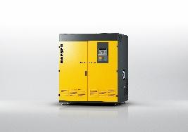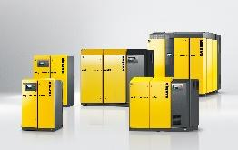
Caption: Turbo blower versus rotary screw blowers.

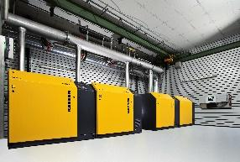
Caption: Modern rotary screw blowers can be arranged side-by-side

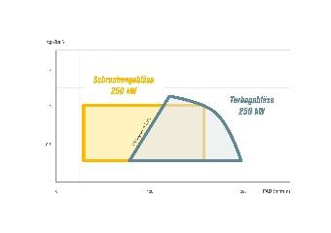
Caption: Depending on the flow rate and control range required, either turbo or rotary screw blowers can be the most suitable.
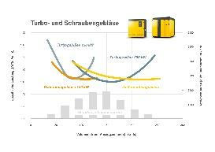
Caption: Operators with a flow rate distribution such as this can benefit most efficiently from a combination of turbo and rotary screw blowers

Kaeser photo(s) – free for publication, credits appreciated.

