May 2021
A mobile and speedy solution:
Compressed air on the go

A sudden increase in production volume, maintenance work, temporary bottlenecks, unexpected production downtimes - there are many reasons why an existing compressed air solution in industrial production can suddenly no longer be sufficient. Mobile compressor solutions provide a remedy where an existing in-house system needs quick and uncomplicated support.

A portable compressor in the middle of production? This may sound irksome at first, but it is in fact an innovative solution when more compressed air is needed unexpectedly and quickly than in the previous production process. Here Kaeser Compressors presents the ideal solution - its Mobilair range of portable compressors featuring electric drives. Not only are they quiet and usually require little space, but above all they are emission-free, so that they can also be set up inside buildings without hesitation.

One example where this solution really comes into its own is when demand for compressed air suddenly exceeds the company’s existing capacity - such as when an unexpected and extensive order for production or manufacture arrives. In this circumstance, the compressed air required will no doubt far exceed the company's current capacity, where an existing compressed air station was designed for normal production only. It is therefore not surprising that the delivery volume is no longer sufficient for additional consumers. But expanding the compressed air supply may not be that easy. A lack of space and connecting lines for the compressed air hoses, for example, could cause issues. So it may not be possible to simply install another stationary screw compressor. Fortunately, there are also mobile versions.

In addition to a space problem in our example, another issue might be the limitation of the existing strength of the power connection, such as in those circumstances where a power connection of a maximum of 32 amps is available, because providing a larger connection would mean shutting down important systems. In addition, if the business is located in the immediate vicinity of a residential area, this increases the requirements once again to include exhaust gas and noise emissions. A mobile compressor with a diesel engine would therefore not be suitable. The solution: a portable compressor with an electric drive.

Whisper-quiet in operation
The Kaeser Mobilair e-power series of portable compressors, have a whisper-quiet electric drive that works completely without exhaust gases. A 32 amp 3 phase socket is sufficient to connect the power pack to the necessary power supply. The compact system delivers 2.6 m³/min at 7 bar. This means that the mobile electric compressor is not only suitable for construction sites, but can also be used as a quick and flexible bridge in the event of a compressed air bottleneck in industry. In addition, its robust construction enables problem-free continuous operation at ambient temperatures between -10 and +40 °C. The integrated hose reel with compressed air hose is also a valuable aid. The missing compressed air lines are no longer a problem. Plug in and production could run.

The solution when things have to be done quickly
Mobile compressors are a sensible alternative if, for example, the compressed air requirement is higher for a certain period of time, if there are unexpected failures or for planned bridging. In the case of temporary expansions, the requirement is covered without the compressor station being unnecessarily oversized for normal operation.

In the event of unexpected failures, speed is of the essence. Mobile compressors can be onsite quickly, ready for immediate use and, thanks to different equipment, deliver compressed air for numerous applications, taking into account the requirements for the environment and compressed air quality.

Even in the case of planned maintenance of the entire station, mobile compressors are quickly brought to their destination and connected to the existing compressed air network. The operator does not even feel that his own compressor is at a standstill. Especially since modern portable compressors can easily be connected to a possibly existing higher-level machine control and manual operation is superfluous.

Mobile compressors are available in different designs, different sizes and with different additional equipment, so that the right version for the operator can always be selected. Common helpers deliver between 2 and 25 m³ of compressed air per minute. In addition to electric drive, diesel engines are also common among the drive types.

For larger requirements and longer deployments, there are also real compressed air giants with an output of 45 m³/ min, which can also work in a network when deployed.

Complete station in a mobile container
In addition to the individual compressors, complete mobile compressed air stations for mobile use are also available, such as Contain-Air from Kaeser Compressors. With this variant, a complete compressed air station is available in a container, which delivers efficient and reliable oil-free compressed air anywhere, mobile, space-saving and quiet.

The use of such a solution makes sense when particularly high demands are placed on the quality of the compressed air. The compact compressed air station supplies every production with oil-free compressed air at short notice and temporarily. The container is equipped with a robust, air-cooled, oil-free compressing screw compressor with an integrated rotary dryer called i.HOC (adsorption dryer).

Standard container dimensions guarantee fast and uncomplicated transport. This equipment is not only space-saving, it also offers important technical advantages. Thanks to the innovative drying process, no condensate forms and no ice in the compressed air line in winter. An additional mobile dryer module is therefore not required. Since oil-free compression in combination with i.HOC drying achieves pressure dew points down to -30 °C, the compressed air can also be used for sensitive production processes.

A suitable mobile solution is therefore possible for every individual requirement. With rental options available from Kaeser Compressors, quick assistance is also on-hand. For more information visit au.kaeser.com or phone 1800 640 611.
-END-
Editors Notes
From 0.18 to 515 kW, Kaeser Compressors manufactures a wide range of compressors and associated auxiliary equipment that meet the varying requirements of a diverse range of industries and applications.

One of the world’s largest manufacturers of rotary screw compressors, Kaeser Compressors is represented globally in over 100 countries through a dedicated network of branches, subsidiary companies and authorised partners.

Kaeser Compressors Australia provides comprehensive sales and service from its 30,000 ft² purpose built factory in Dandenong, Victoria alongside an extensive network of sales and service centres and authorised partners that cover Australia and New Caledonia.

For editorial and advertising enquiries contact: Beth Wood, Marketing Manager
Press office: +61 3 9791 5999 Fax: +61 3 9791 5733
E-mail: beth.wood@kaeser.com

KAESER COMPRESSORS Australia Pty Ltd
45 Zenith Road, Dandenong, VIC 3175, Australia
Phone: +61 3 9791 5999 Email: info.australia@kaeser.com
au.kaeser.com

File: C-Mobilair-Apr21-aus
Approved for publication, copy acknowledgement appreciated

Images:
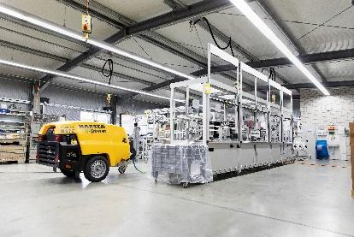
Caption: Mobile compressors are a good solution when compressed air is required quickly. Mobile compressors with an electric drive, can also be set up inside buildings.

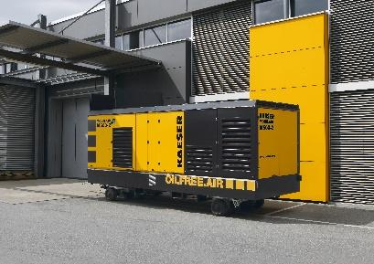
Caption: For large and oil-free compressed air requirements, compressors such as the M 500-2 are available.

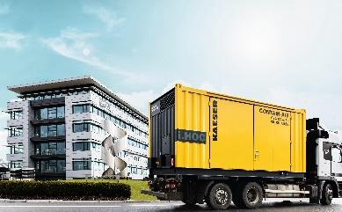
Caption: A complete compressed air system, including treatment in a mobile container solution.

Kaeser photo(s) – free for publication, credits appreciated.

