February 2021
Building for the future:
Kaeser breaks ground on new state-of-the-art facility

Kaeser Compressors Australia recently celebrated breaking ground on the construction of its new state-of-the-art head office facility in Melbourne. After a number of COVID-19 setbacks, the transformation is well underway and expected to be completed by early 2022.
Peter Eckberg, Managing Director of Kaeser Compressors Australia said: ‘Construction of our new head office facility should have commenced in 2020. Unfortunately, COVID-19 had other plans! While the pandemic may have slowed down proceedings it has not stopped the company’s reinvestment plans. Kaeser Compressors has always reinvested heavily into the business and the current pandemic has not halted those efforts. We’re pleased to say that despite on-going COVID-19 disruptions, we finally broke ground in January.’

The Australian head office has been situated in Dandenong, Victoria since Kaeser Compressors opened its doors in 1990. 30 years later and it was clear that the company was outgrowing the existing facility, and required additional office space, a larger warehouse and a bigger in-house workshop.

A complete transformation of the current facility is now underway which will both modernise and extend it out to twice its current size. You can stay up-to-date with construction progress by visiting au.kaeser.com
-END- Free for publication, copy appreciated
Editors Notes
From 0.18 to 515 kW, Kaeser Compressors manufactures a wide range of compressors and associated auxiliary equipment that meet the varying requirements of a diverse range of industries and applications.

One of the world’s largest manufacturers of rotary screw compressors, Kaeser Compressors is represented globally in over 100 countries through a dedicated network of branches, subsidiary companies and authorised partners.

Kaeser Compressors Australia provides comprehensive sales and service from its 30,000 ft² purpose built factory in Dandenong, Victoria alongside an extensive network of sales and service centres and authorised partners that cover Australia and New Caledonia.

For editorial and advertising enquiries contact: Beth Wood, Marketing Manager
Press office: +61 3 9791 5999 Fax: +61 3 9791 5733
E-mail: beth.wood@kaeser.com

KAESER COMPRESSORS Australia Pty Ltd
45 Zenith Road, Dandenong, VIC 3175, Australia
Phone: +61 3 9791 5999 Email: info.australia@kaeser.com
au.kaeser.com
File: P-Groundbreaking-Melb-aus
Approved for publication, copy acknowledgement appreciated
Image:
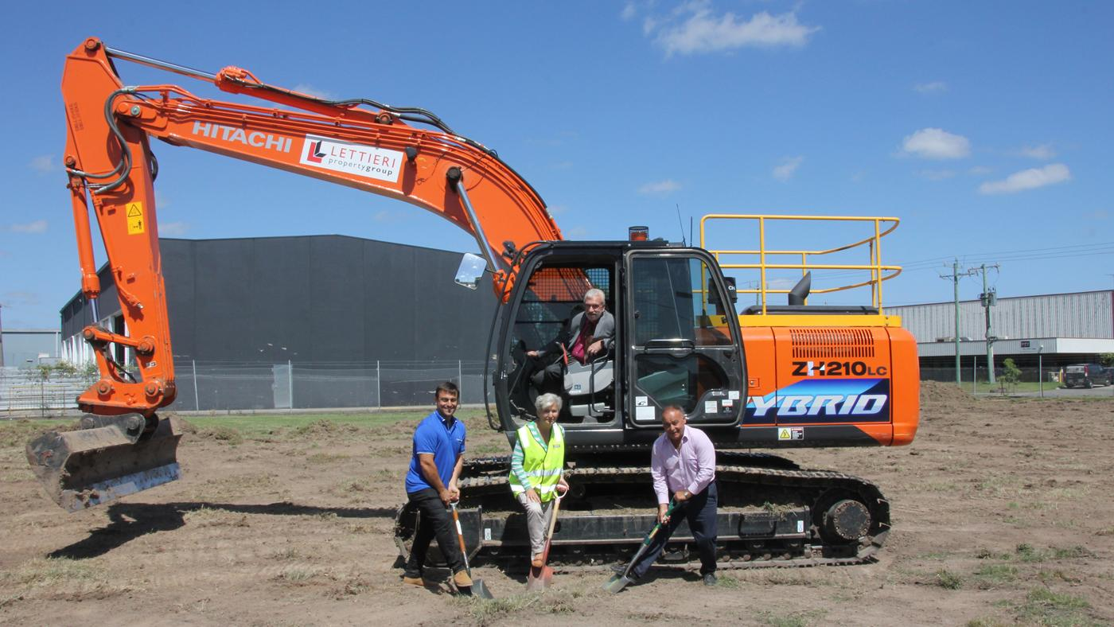
Caption: Kaeser Compressors Australia breaks ground in its new facility. Pictured from left to right; Tony Lettieri (Lettieri Property Group), Rada Eckberg (Kaeser Compressors), Peter Eckberg (Kaeser Compressors) and Tony Letteri (Lettieri Property Group).

Kaeser photo(s) – free for publication, credits appreciated.

