June 2022

Kaeser expands its range of high efficiency rotary screw blowers:
Peak performance at high flow rates

Kaeser has just announced the launch of the GBS series which compliments its already well established range of rotary screw blowers. The GBS series sets a new benchmark in compressor technology for the 75 to 160 kW power range, with a flow rate from 22 to 104 m³/min and differential pressures up to 1100 mbar. These machines not only feature exceptional control characteristics, quiet operation, an optimised footprint and low maintenance requirements - but they also deliver consistently high efficiency across the entire control range.

The GBS series of rotary screw blowers from Kaeser draws on decades of expertise in the development of highly efficient rotary screw compressors and automation technology, as well as extensive experience in delivering smart machines that can meet the needs of Industrie 4.0 environments.

Like all other Kaeser rotary screw blowers, the GBS series models are up to 35 percent more efficient than conventional rotary lobe blowers. They also deliver significant energy advantages compared to many other rotary screw blowers and turbo compressors available on the market. Whatsmore, the efficiency of the GBS series rotary screw blowers remains consistent across the control range, rather than just at certain points, which makes them a particularly attractive alternative to turbo compressors.

Power transmission from the motor to the compressor is via loss-free, maintenance-free gearing, which means that the GBS series models impress with highly efficient operation and low maintenance requirements. And, these blowers are designed for space-saving installation and exceptionally quiet operation.

For fixed speed operation, Start Control (STC) versions are available. They feature an integrated star-delta starter equipped with a premium contactor, overcurrent relay and phase monitoring. The STC versions additionally feature an energy-saving IE4 Super Premium Efficiency motor.

Sigma Frequency Control (SFC) versions are also available, and feature an integrated frequency converter for dynamic adjustment of the flow rate to actual demand, with the frequency converter and motor perfectly matched to deliver consistently optimised overall efficiency. For power outputs up to 110 kW, particularly efficient synchronous reluctance motors are used.

In order to ensure that the predicted high savings are translated into reality, Kaeser guarantees the power consumption per unit of flow rate (specific power consumption in kW per m³/h) in accordance with the narrow tolerances of ISO 1217, Annexe E. An end user can therefore enjoy the peace of mind that comes with guaranteed accuracy of the projected savings and amortisation periods.

The integrated Sigma Control 2 controller ensures operational reliability and smart communication via integration into process control systems, including those with Industrie 4.0 requirements. The Sigma Air Manager 4.0 master controller is recommended for blower stations with multiple blowers, as it features control and regulation algorithms specially developed for the needs of low-pressure applications. This enables even greater energy savings and simplification of automation.

Applications with especially high energy requirements - such as the production of air for aeration in wastewater treatment facilities and bioreactors, as well as for flotation and fluidisation - are sure to benefit from this advanced automation and compressor technology from Kaeser.

The GBS series models are available to order from September 2022. For more information visit au.kaeser.com or phone 1800 640 611.
-END- Free for publication, copy appreciated
Editors Notes
From 0.18 to 515 kW, Kaeser Compressors manufactures a wide range of compressors and associated auxiliary equipment that meet the varying requirements of a diverse range of industries and applications.
One of the world’s largest manufacturers of compressors, blowers and compressed air systems, Kaeser Compressors is represented throughout the world by a comprehensive network of branches, subsidiaries and authorised distribution partners in over 140 countries.

Kaeser Compressors Australia provides comprehensive sales and service from its purpose built factory in Dandenong, Victoria alongside an extensive network of sales and service centres and authorised partners that cover Australia and New Caledonia.

For editorial and advertising enquiries contact: Beth Wood, Marketing Manager
Press office: +61 3 9791 5999 E-mail: beth.wood@kaeser.com

KAESER COMPRESSORS Australia Pty Ltd
45 Zenith Road, Dandenong, VIC 3175, Australia
Phone: +61 3 9791 5999 Email: info.australia@kaeser.com
au.kaeser.com
File: H-GBS-1050-aus
Approved for publication, copy acknowledgement appreciated

Images:
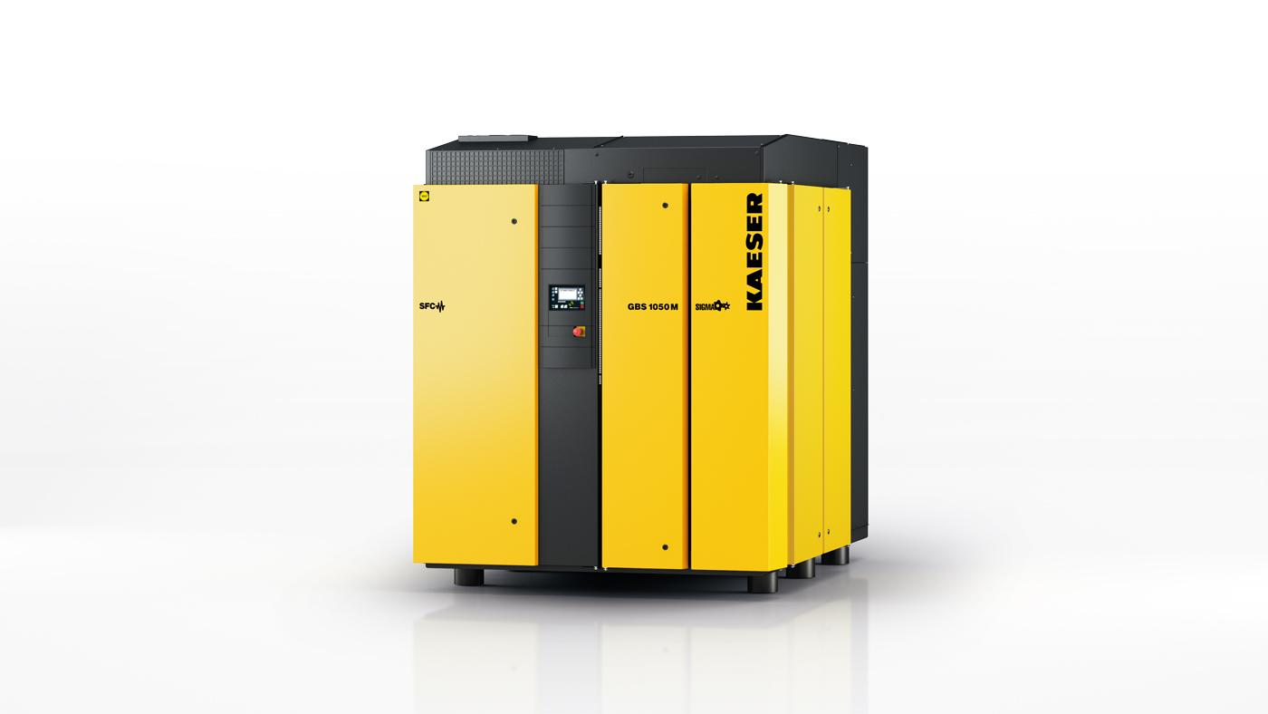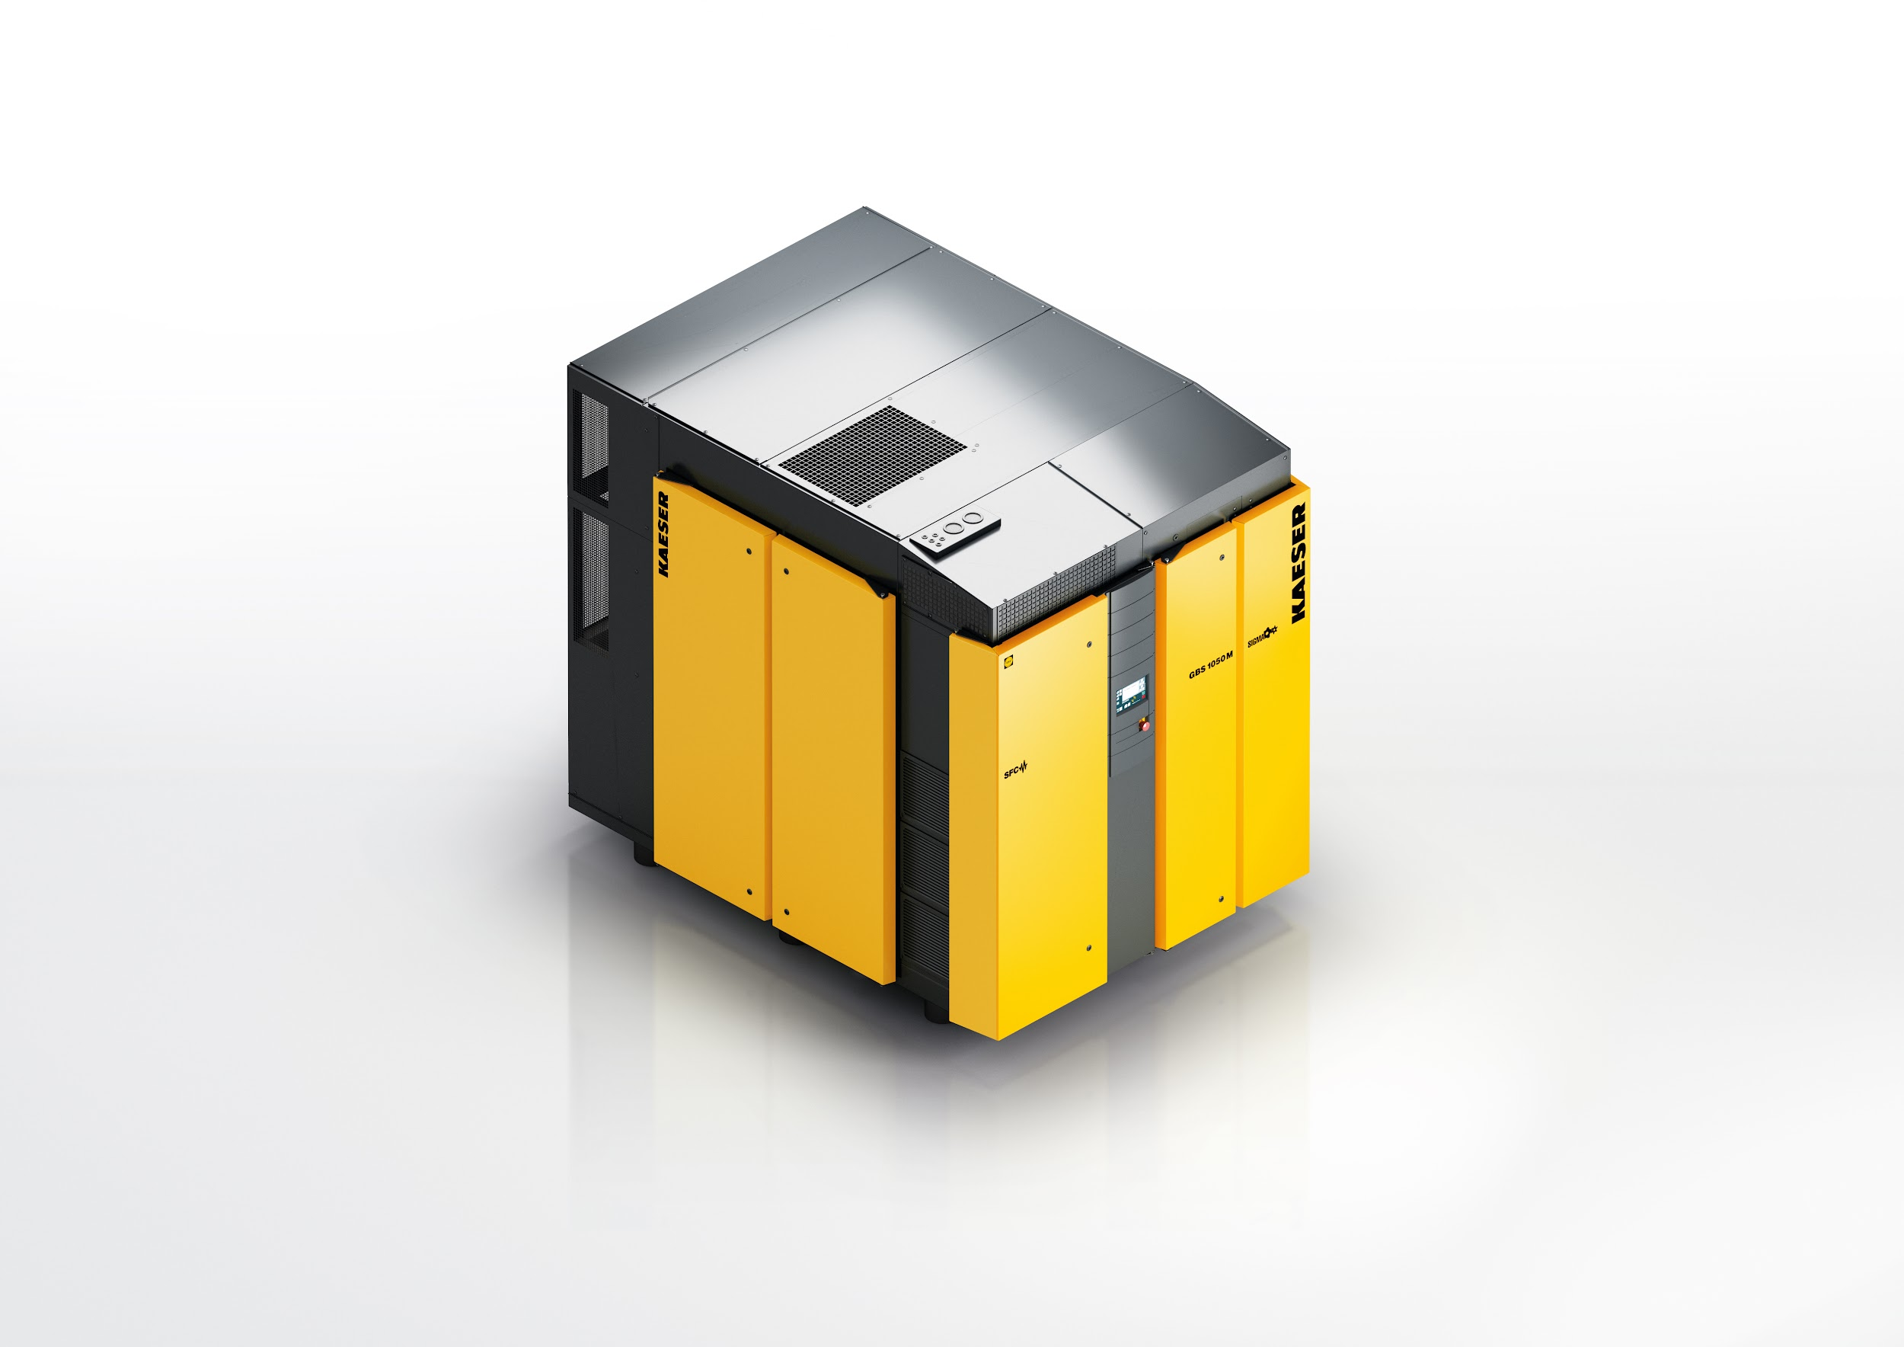
Caption: The recently launched GBS series of rotary screw blowers from Kaeser, set a new benchmark in compressor technology for the 75 to 160 kW power range, with a flow rate from 22 to 104 m³/min and differential pressures up to 1100 mbar.
((Kaeser photo – free for publication))

