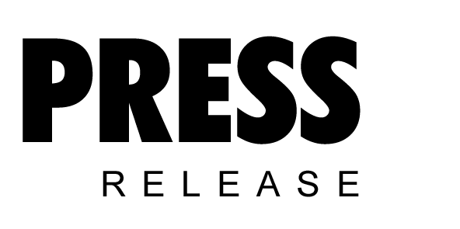

October 2019

‘Tis the season to get planning:
Compressed air system maintenance planning for the festive shutdown

With the festive season just around the corner, it is the ideal time to start planning your compressed air maintenance requirements and any other major projects you want to complete within this shutdown period. Here Kaeser Compressors discusses why maintenance planning is essential in order to take full advantage of the extended festive shutdown period.

Meeting production requirements can often make it tough to schedule in downtime for essential compressed air system maintenance. Following the OEM’s (original equipment manufacturers) prescribed maintenance schedule is essential however to ensure that a compressed air system continues to reliably produce high quality compressed air. Failure to do so could lead to costly and unplanned downtime as well as premature wear of components and consumables. And, together this could also have a negative impact on the expected life of the compressed air equipment.
However, even if you follow the prescribed maintenance schedule, there will of course be larger maintenance jobs that need to be completed which take longer to do. The festive season often presents the ideal time.

Holiday shutdown
The festive season is one of the longest periods of time in the year when most manufacturers will shutdown. Usually between Christmas and New Year, this period presents the perfect opportunity to schedule in larger maintenance tasks with your compressed air service provider.
Some common compressed air system maintenance tasks that require a longer shutdown period include; replacing motor bearings, removing and cleaning coolers as well as oil/water separator cleaning and replacement.

As the festive period falls towards the beginning of summer, the shutdown period is also the ideal time to perform a number of routine maintenance tasks which will ensure your compressed air system is ready for the hot weather ahead:

Hot weather can put a lot of stress on your compressed air system, and as the temperature starts to rise so can a number of maintenance issues. Maintenance tasks such as; changing the oil and the inlet filter to checking the fluid system, belts and couplings are just a few that are beneficial to undertake at the start of summer in order to prepare your compressed air system for the hotter months.

Keeping your coolers clean is actually one of the most important things you can do during the summer months. Dirty coolers can cause a number of problems not least contribute to your compressor running hot. And, elevated running temperatures increase oil carry over from your compressor which will eventually lead to a low oil level and ultimately a compressor shutdown. Depending on the state of your coolers, high pressure cleaning and/or ultrasonic cleaning may be advised. Again, an extended shutdown period presents the ideal time to have your coolers cleaned.

The festive shutdown period could also be used to implement any system upgrades or improvements you have been considering. Some examples may be getting on top of compressed air leak detection and repairs to installing new line filtration if required to improve air quality.

It could also be the perfect opportunity to install a bypass line if you don’t already have one. A bypass line allows the compressed air user to be able to continue to transport compressed air through the system while e.g. line filtration is maintained. However, a bypass line can often be overlooked when a compressed air system is installed. Installing a bypass line would therefore mean that any future work required on line filtration will not have to wait until longer shutdown periods.

The key to success
Maintenance planning is the key to success. And, consulting your compressed air service provider in advance of your shutdown period will allow you to discuss together what maintenance jobs need to be conducted. Not only can you then get your service visit booked in, but you can also place an order for the required consumables, spare parts and so on that will be required, ensuring they are all available and ready to go.
It would also be worth looking over the oil sample analysis results with your compressed air service provider that have been taken as part of your routine preventative maintenance visits over the past 12 months. This will identify any trends and if anything else needs corrective action. If any issues are detected, recommendations can be made and actions planned, preventing potential future costly repairs, breakdowns or shutdowns. If recommendations are made, it may well be the case that some if not all of them can be scheduled in to be actioned over the shutdown period.

Optimum results
The festive shutdown can be a very productive period for a business in terms of undergoing required compressed air system service and maintenance work as well as making system improvements or upgrades. To get the optimum outcomes however, maintenance planning in the run up to the festive season is essential.

For further advice or more information visit au.kaeser.com or phone 1800 640 611.
-END-
Editors Notes
From 2.2 to 500 kW, Kaeser Compressors manufactures a wide range of compressors and associated auxiliary equipment that meet the varying requirements of a diverse range of industries and applications.

One of the world’s largest manufacturers of rotary screw compressors, Kaeser Compressors is represented globally in over 100 countries through a dedicated network of branches, subsidiary companies and authorised partners.

Kaeser Compressors Australia provides comprehensive sales and service from its 30,000 ft² purpose built factory in Dandenong, Victoria alongside an extensive network of sales and service centres and authorised partners that cover Australia, New Zealand and New Caledonia.

For editorial and advertising enquiries contact:
Press office: +61 3 9791 5999 Fax: +61 3 9791 5733
E-mail: info.australia@kaeser.com

KAESER COMPRESSORS Australia Pty Ltd – 45 Zenith Road, Dandenong South, VIC 3175, Australia
Phone: +61 3 9791 5999 – https://au.kaeser.com – E-mail: info.australia@kaeser.com

File: N-maintenance-planning-aus
Approved for publication, copy acknowledgement appreciated
Images:

((Captions)) :

Images:
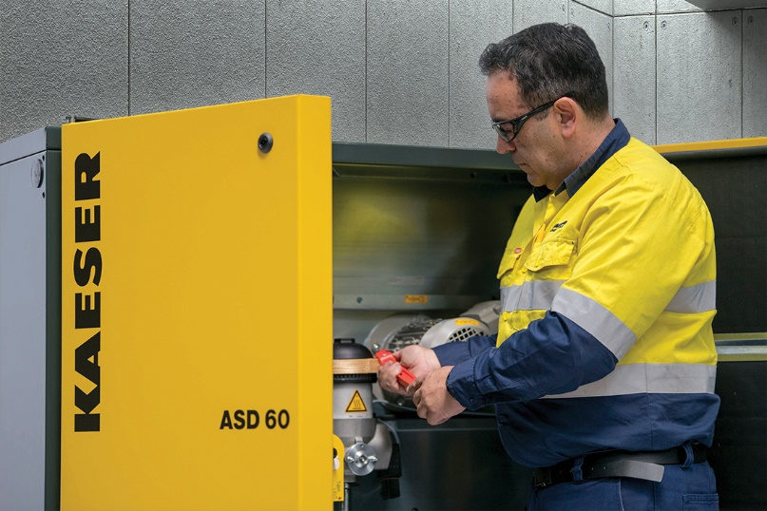
023_Image 1_Kaeser service.jpg
Caption: The festive shutdown is the perfect time to schedule in larger compressed air maintenance tasks.
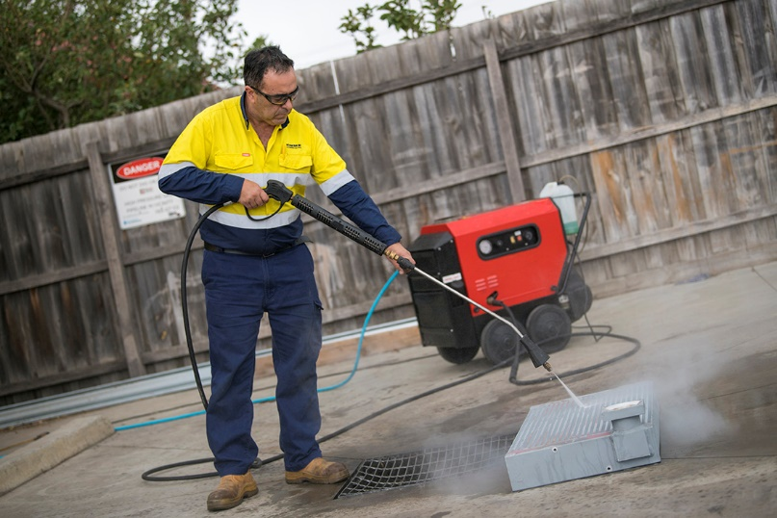
023_Image 2_Kaeser cooler cleaning.jpg
Caption: An extended shutdown period presents the ideal time to have coolers cleaned.

((Kaeser photo – free for publication))

