Kaeser brings Industrie 4.0 to low pressure applications
Why buy incomplete single devices when it’s possible to enjoy a fully networked complete station that provides full access to vital operating data from anywhere: Industrie 4.0 has arrived in the blower segment, bringing maximum energy efficiency, availability and sophisticated data analysis.
The Sigma Air Manager 4.0 master controller, which previously revolutionised the rotary screw compressor segment, is now also available for blowers, and it is the key technology which will allow users to benefit from Industrie 4.0 services. It also forms the heart of a Kaeser blower station, acting intelligently to control the individual machines for optimal efficiency and adjusting their flow rate perfectly to the overall flow rate demand profile.
The Sigma Air Manager 4.0 analyses operating data in a matter of seconds, simulates alternative management scenarios and selects the most efficient option. The bottom line: users benefit from previously unimaginable energy efficiency.
Additionally, the multi-device control of the Sigma Air Manager 4.0, opens up new possibilities for the advance planning of blower maintenance. Whereas previously maintenance would only have been possible when fault messages occurred or as part of scheduled servicing, with the Sigma Air Manager 4.0, it is now possible to initiate maintenance work before faults occur. This assists in avoiding downtime and the further damage that faults may cause.
Of course, these powerful capabilities can only be harnessed when the components of a station deliver consistently efficient performance – which is precisely what users can expect from the DBS, EBS and FBS screw blower series from Kaeser. Their superior efficiency outshines both the competition as well as predecessor models. Compared to conventional rotary blowers, the new Kaeser screw blowers are up to 35 percent more efficient, whilst also offering significant double-digit energy advantages over many commonly available screw and turbo blowers on the market.

File: h-Ind 4.0 blowers-aus
Approved for publication, copy acknowledgement appreciated
Image:

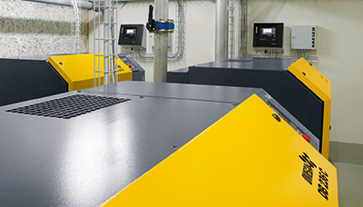
The Sigma Air Manager 4.0 not only monitors and controls all components of a blower station with maximum efficiency, it also lays the foundation for Industrie 4.0 technology and services.

