February 2019

Kaeser at Austech 2019: needs-based compressed air production

Highly efficient compressors, effective compressed air treatment systems, smart engineering and intelligent services - Kaeser will be showcasing a wide range of its compressed air solutions at Austech that reveal the modern face of needs-based air production.

Visitors to the Kaeser stand AT50 at Austech will be able to learn more about Kaeser’s highly efficient, effective and smart compressed air solutions that deliver needs-based air production. For the end user this translates in to more compressed air and more energy savings.

Kaeser will be showcasing a complete compressed air system at Austech. This includes the compact and highly efficient SK series of rotary screw compressors. Featuring the energy saving Sigma Profile screw compressor block rotors, a premium efficiency IE3 motor and the Sigma Control 2 controller, the SK series from Kaeser provide both outstanding efficiency and reliability. In fact, not only do they deliver more compressed air for less power consumption, but they also combine ease of maintenance with exceptional versatility and environmentally responsible design.

Sophisticated compressed air treatment and condensate technology go a long way to ensuring a compressed air system remains reliable and efficient. Amongst the compressed air treatment system on display on the Kaeser stand at Austech will be a Kryosec series refrigeration dryer.
The Kryosec compact range of refrigeration dryers deliver outstanding performance with ‘Made in Germany’ industrial quality and reliable moisture protection in ambient temperatures up to +50ºC.

When it comes to needs-based air production, a key technology that Kaeser has to offer is the Sigma Air Manager 4.0 compressed air controller. This smart controller is the central mastermind that controls the entire compressed air supply and a key Industrie 4.0 compressed air technology. It enables optimal coordination and control of all components within a compressed air station, precisely matching air delivery with the required airflow profile to meet the end user’s exact requirements. Within seconds it analyses the operating data, simulates possible responses and selects the most effective option. The result: smart needs-based air production.

Join Kaeser at Austech on stand AT50 to discover the latest in compressed air technologies as well as obtain expert advice from Kaeser’s team of compressed air specialists. For more information from Kaeser visit www.kaeser.com.au or phone 1800 640 611.
-END-
Editors Notes
From 2.2 to 500 kW, Kaeser Compressors manufactures a wide range of compressors and associated auxiliary equipment that meet the varying requirements of a diverse range of industries and applications.

One of the world’s largest manufacturers of rotary screw compressors, Kaeser Compressors is represented globally in over 100 countries through a dedicated network of branches, subsidiary companies and authorised partners.

Kaeser Compressors Australia provides comprehensive sales and service from its 30,000 ft² purpose built factory in Dandenong, Victoria alongside an extensive network of sales and service centres and authorised partners that cover Australia, New Zealand and New Caledonia.

For editorial and advertising enquiries contact:
Press office: +61 3 9791 5999 Fax: +61 3 9791 5733
E-mail: info.australia@kaeser.com

KAESER COMPRESSORS Australia Pty Ltd – 45 Zenith Road, Dandenong South, VIC 3175, Australia
Phone: +61 3 9791 5999 – www.kaeser.com.au – E-mail: info.australia@kaeser.com

File: O-Austech-2019-preview-aus
Approved for publication, copy acknowledgement appreciated
Image:
((Captions)) :
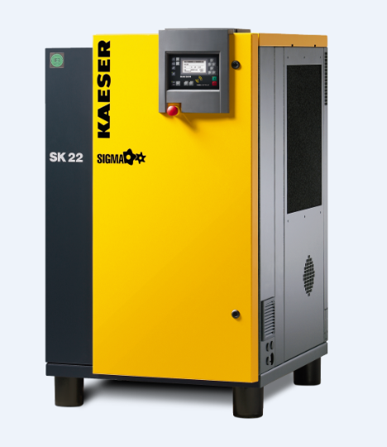

006_Image 1_KAESER SK22.png
Caption: The Kaeser SK series rotary screw compressors are compact, reliable and efficient
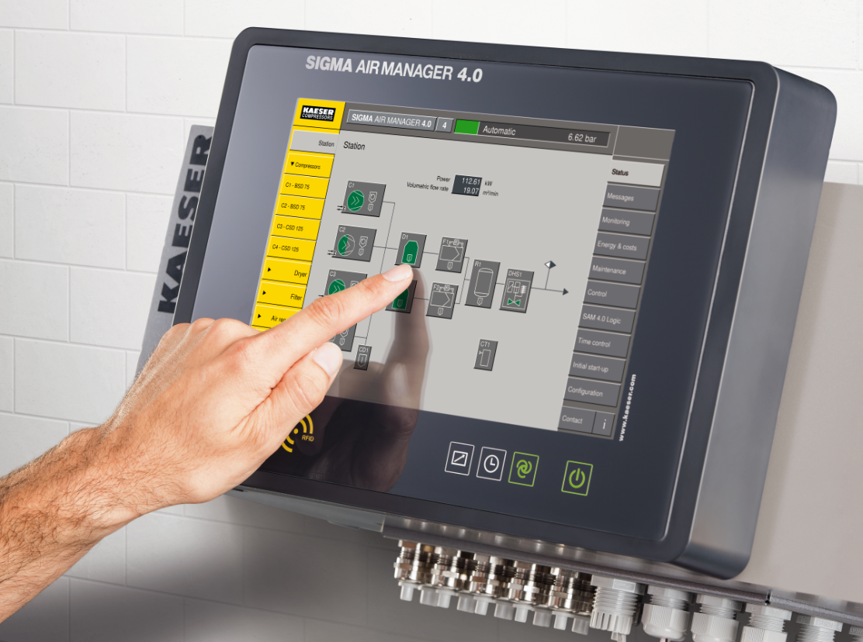
006_Image 2_KAESER SAM 4 0.png
Caption: The Sigma Air Manager 4.0 from Kaeser is a key technology in the production of needs-based compressed air
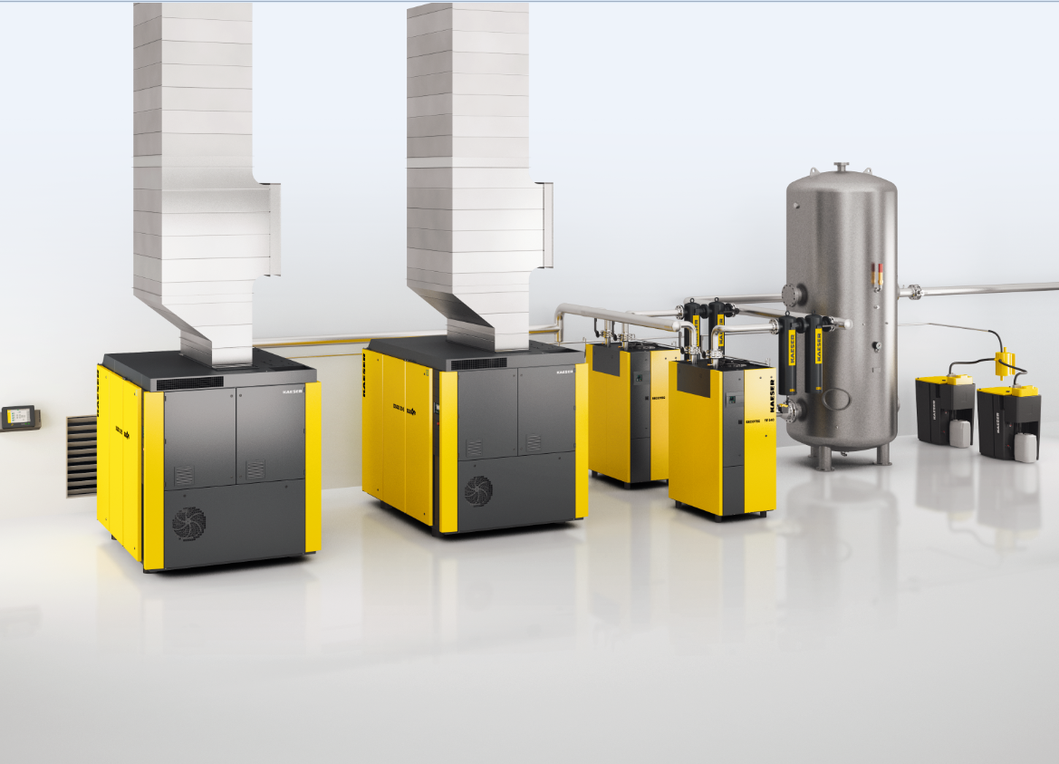
006_Image 3_KAESER compressed air station.png
Caption: Kaeser will showcase a complete compressed air station at Austech

((Kaeser photo – free for publication))

