July 2019

Future-proof compressed air refrigerant drying

All refrigerant dryers from Kaeser Compressors will use the new R-513A refrigerant by the end of 2019. Utilising this climate-friendly refrigerant will assist compressed air users in future-proofing their system as Australia transitions to low-GWP refrigerants as part of the Australian HFC phase-down.

Nearly every compressed air station uses refrigeration dryers, since most applications require these machines to deliver a dependable supply of quality dried compressed air.
The European F-gas regulation EU 517/2014 has been in force since 2015. This is intended to minimise the emissions of partly-fluorinated greenhouse gases (F-gases) as well as phase-down the sale of HFCs (hydrofluorocarbons), as both significantly contribute to global warming.

This legislation has impacted European manufacturers and operators of compressed air stations because F-gases are used as refrigerants in refrigeration dryers and the refrigerants used up until now are being withdrawn from the market. All refrigerant dryers from Kaeser Compressors will therefore use the new R-513A refrigerant by the end of 2019. It is climate-friendly and provides users with peace of mind when it comes to future-proofing their operation.

This is also good news for Australian compressed air users wanting to future-proof their compressed air station, as Australia transitions to low-GWP refrigerants as part of the Australian HFC phase-down. Introduced by the Federal Government, the Australian HFC phase-down commenced in January 2018 as part of Australia’s international commitment to the Kigali Amendment to the Montreal Protocol. This sets a quota on the import of specified high-GWP (Global Warming Potential) refrigerants. The HFC phase-down will significantly reduce the amount of high-GWP refrigerants in Australia by gradually reducing the import quota from 100% in 2018 to 15% by the end of 2036.

Kaeser is supporting all customers to convert their systems to a more environmentally-friendly alternative. When planning the purchase of a new dryer, consideration should be given to make sure that the unit uses a refrigerant that will be easy and cost effective to source for future service work. Some manufacturers use materials that are legal today, but which will eventually become prohibited in some countries, or which will simply no longer be offered, due to their high global warming potential. This means that those operators who use these materials will soon be faced with the same problem. Kaeser is aware of this issue and is taking early preventative countermeasures accordingly.

It rarely makes sense to retrofit older but functional machines to use new refrigerants. Operators are well advised to take note of the currently-used refrigerants in their equipment and to obtain information regarding alternative strategies. Kaeser’s experienced and certified personnel are available to assist end users. Certified service is advisable for all refrigeration dryers in order to provide different solutions with regards to this subject; this is especially true for older systems where refrigerant conversion is uneconomical.

All Kaeser refrigeration dryers are designed to provide maximum efficiency and energy cost savings. Thanks to the new refrigerant, they are also future-proof for their entire service life when it comes to applicable refrigerant legislation. Moreover, they are exceptionally efficient, require minimal maintenance and are easy and quick to service.

For more information from Kaeser visit www.kaeser.com.au or phone 1800 640 611.
-END-
Editors Notes
From 2.2 to 500 kW, Kaeser Compressors manufactures a wide range of compressors and associated auxiliary equipment that meet the varying requirements of a diverse range of industries and applications.

One of the world’s largest manufacturers of rotary screw compressors, Kaeser Compressors is represented globally in over 100 countries through a dedicated network of branches, subsidiary companies and authorised partners.

Kaeser Compressors Australia provides comprehensive sales and service from its 30,000 ft² purpose built factory in Dandenong, Victoria alongside an extensive network of sales and service centres and authorised partners that cover Australia, New Zealand and New Caledonia.

For editorial and advertising enquiries contact:
Press office: +61 3 9791 5999 Fax: +61 3 9791 5733
E-mail: info.australia@kaeser.com

KAESER COMPRESSORS Australia Pty Ltd – 45 Zenith Road, Dandenong South, VIC 3175, Australia
Phone: +61 3 9791 5999 – www.kaeser.com.au – E-mail: info.australia@kaeser.com

File: D-R513a-aus
Approved for publication, copy acknowledgement appreciated
((Captions)) :

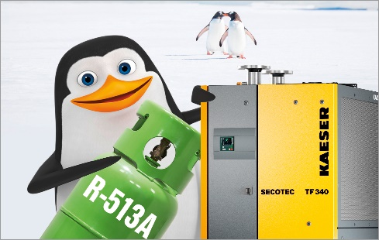

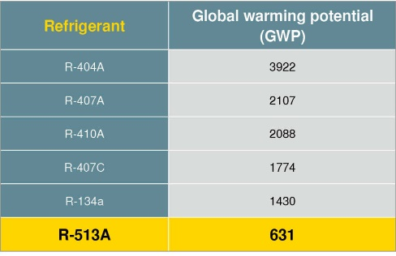
Caption: R-513A refrigerant offers the most future-proof operating solution for refrigeration dryers. All KAESER refrigeration dryers will use this environmentally-friendly and safe alternative by the end of 2019.

016_Image 1_Kaeser refrigerant dryer.jpg
016_Image 2_refrigerant table.jpg
((Kaeser photo – free for publication))

