September 2020

Take the benefits outdoors:
Large electric-drive portable compressors made for tough outdoor environments

Zero emissions and substantial savings in operating costs are just two of the benefits that portable compressed air users can enjoy with the Mobilair e-power series of portable compressors from Kaeser Compressors. A true alternative to conventional models, these rugged electric-drive portable compressors may be the ideal alternative wherever a power supply is available.

Environmentally friendly, powerful and efficient, Mobilair e-power units from Kaeser Compressors have been designed specifically for operation outdoors - wherever a power supply is available. The range was recently extended to include the M250E and M255E stationary portable compressor models. These mobile powerhouses - with drive powers from 132 to 160 kW - are robust, low-maintenance and easy to transport wherever they are needed.

The Mobilair M250E and M255E can be used either as a temporary solution to expand the capacity of an existing compressed air station, or as a permanent outdoor installation for industrial applications. They are particularly suited for use in locations where no compressor room is available, such as in mines, tunnels or shipyards.

Substantial operating cost savings can be achieved with these new systems in multiple ways:
At the heart of these systems lies a flow-optimised and premium-quality rotary screw compressor block with energy-saving Sigma Profile rotors. Optimised flow characteristics ensure the system delivers more compressed air for less energy output. Thanks to its 1:1 drive, the motor further ensures low speeds of 1500 1/min at 50 Hz resulting in enhanced service life.
The use of IE4 super premium efficiency motors (that comply with, and exceed prevailing Australian GEMS regulations for 3 phase electric motors) additionally deliver maximum performance and energy efficiency. IE4 motors are the technology of tomorrow, as current regulations introduced in January 2015 simply require the use of IE3 class motors.
Moreover, the electric drive motor is emissions-free and therefore particularly environmentally-friendly, and with sound levels at just 70 dB(A), these e-power Mobilair systems are also very quiet in operation.

Where power hook-ups are available, these electric compressors make even more sense, as electricity is generally much cheaper than diesel fuel. Another advantage: electric compressors cost far less to maintain. All maintenance parts are easily accessed via large doors, and service work is quick and simple, thanks to features such as the externally mounted drainage outlets for quick compressor fluid changes.

Compact dimensions allow these units to operate in locations where space is at a premium. They are also built to be moved quickly and easily from place to place. The narrow footprint is optimised for transport. Two units can be accommodated side-by-side on one HGV loading bed. Lifting eyes are fitted for the purposes of load-securing, whilst enormous skids enable the units to be easily moved into position. The skids also protect the underside of the body from damage.

The M250E has a drive output of 132 kW and delivers flow rates of up to 25 m³/min at 8.6 bar, while the M255E has a drive output of 160 kW delivers flow rates of up to 24.7 m³/min at 10 bar or 19.9 m³/min at 12 bar. Thanks to robust technology and a star-delta starter, the standard units are capable of operating in temperatures from -10°C up to +45°C. For more information visit au.kaeser.com or phone 1800 640 611.
-END- Free for publication, copy appreciated
Editors Notes
From 0.18 to 515 kW, Kaeser Compressors manufactures a wide range of compressors and associated auxiliary equipment that meet the varying requirements of a diverse range of industries and applications.

One of the world’s largest manufacturers of rotary screw compressors, Kaeser Compressors is represented globally in over 100 countries through a dedicated network of branches, subsidiary companies and authorised partners.

Kaeser Compressors Australia provides comprehensive sales and service from its 30,000 ft² purpose built factory in Dandenong, Victoria alongside an extensive network of sales and service centres and authorised partners that cover Australia and New Caledonia.

For editorial and advertising enquiries contact: Beth Wood, Marketing Manager
Press office: +61 3 9791 5999 Fax: +61 3 9791 5733
E-mail: beth.wood@kaeser.com

KAESER COMPRESSORS Australia Pty Ltd
45 Zenith Road, Dandenong, VIC 3175, Australia
Phone: +61 3 9791 5999 Email: info.australia@kaeser.com
au.kaeser.com
Kaeser photo(s) – free for publication, credits appreciated.

File: C-M255E-Sep20-aus
Approved for publication, copy acknowledgement appreciated
Image(s):
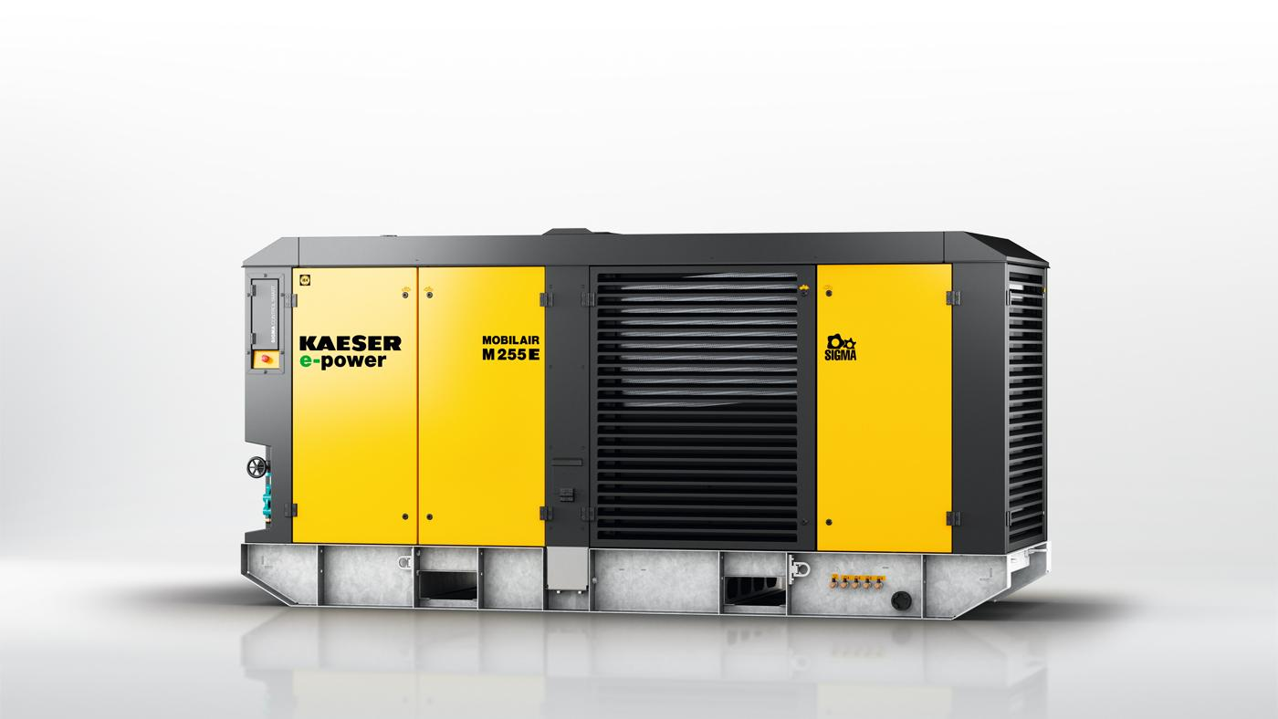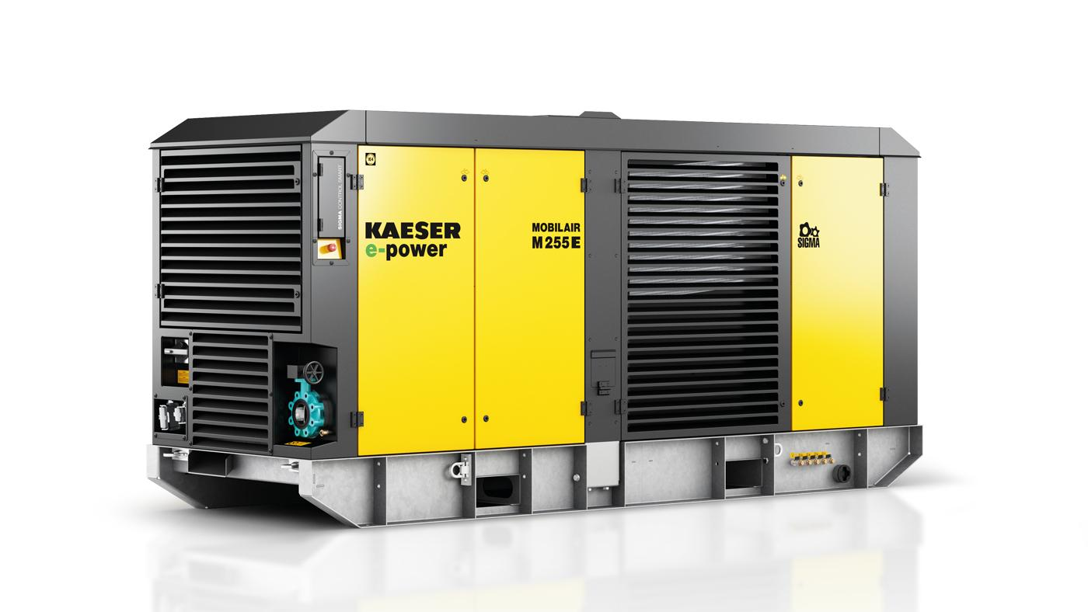
Caption: The Mobilair e-power portable compressors from Kaeser are made for tough outdoor environments.
Kaeser photo(s) – free for publication.

