More air and more savings with the new Kaeser DSD.3 series rotary screw compressors

Kaeser Compressors has just announced the launch of its latest generation DSD series rotary screw compressors. The DSD.3 series models set new standards in performance, availability and energy efficiency.
Kaeser is once again pushing the boundaries of compressed air efficiency and availability with its latest generation DSD.3 series rotary screw compressors;
At the heart of every DSD.3 series compressor is a high performance Kaeser rotary screw compressor block equipped with the flow-optimised and energy saving ‘Sigma Profile’ rotors. In these next generation models, the Sigma profile rotors have been further refined. Together with additional optimisation measures, the new DSD.3 series machines therefore boast up to six percent better power performance compared with previous models. They also include a ‘super premium efficiency’ IE4 electric motor that complies with and exceed prevailing Australian GEMS regulations for 3 phase electric motors, whilst also contributing to lower energy costs. In addition, transmission losses associated with gear or belt drive solutions are further eliminated with these 1:1 direct drive systems.
All models feature a built-in Sigma Control 2 industrial PC-based compressor controller that is responsible for dynamically adjusting the flow rate to match actual compressed air demand thereby assuring further energy savings.
Relevant information can be viewed at a glance from the easy to read display. Unique RFID technology further assures secure login, meaning that service work and system changes to the compressor can only be performed by authorised personnel. Energy saving control modes, variable communication interfaces for communication with centralised control systems, and an SD card for update and backup are just some of the many features available on the Sigma Control 2.
An innovative and sensor-controlled electronic thermal management (ETM) system can be found in the latest generation DSD series rotary screw compressors. The ETM dynamically controls the screw compressor block discharge temperature. The control valve actuator is controlled via signals from the Sigma Control 2 controller, which is coordinated with the oil cooler’s speed controlled fan. For the end user, avoiding unnecessarily high screw compressor block discharge temperatures leads to reduced energy consumption and potentially a longer fluid service life.
The latest generation DSD series rotary screw compressors from Kaeser are also available with heat recovery. All models can be optionally equipped with an integrated fluid / water plate-type exchanger and an additional fluid-thermal valve. The Sigma Control 2 controls the compressor temperature to ensure that hot process water supplied by the heat recovery system attains the desired water outlet temperature. In addition, if all of the heat energy is drawn off by the heat recovery system, the Sigma Control 2 detects that cooling is no longer required at the package cooler and the fan on the oil cooler is shut down. This saves fan power at the oil cooler, thereby reducing energy costs.
In addition, if heat recovery is not required it can simply be deactivated via the Sigma Control 2. This has the advantage that the package reverts to operation with the lowest possible screw compressor block discharge temperature – creating further energy savings.
Where absolutely dry compressed air is required, the DSD.3 series models are available with an integrated refrigeration dryer (DSD T). Energy saving, environmentally conscious and compact the DSD.3 T models incorporate a new refrigeration dryer that requires 25 percent less power than the previous models. The refrigerant quantity has also been reduced to only 2 kg. In addition, this compact powerhouse now has a smaller footprint which has been reduced by around 17 percent on the previous generation.
The DSD series remains service friendly with all maintenance components easily accessible. By making maintenance and service work tasks quicker, operating costs are reduced and availability is increased.
The Kaeser DSD.3 series rotary screw compressors are available air- or water- cooled, with drive power 75 to 132 kW, working pressure 5.5 to 15 bar and free air deliveries from 3.6 to 25.45 m³/min. They are available as a standard machine, with integrated refrigeration dryer and/or with Sigma Frequency Control.

File: A-DSD_3-aus
Approved for publication, copy acknowledgement appreciated

Images:
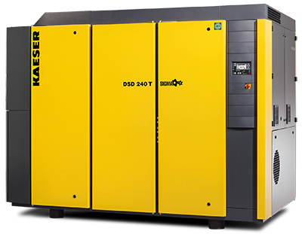
The DSD.3 series models from Kaeser set new standards in performance, availability and energy efficiency.

