Katere Coatings blast $10,000 per annum off its energy bill with Kaeser
Kaeser Compressors has assisted Katere Coatings in creating energy savings in excess of $10,000 (AUD) per annum. This significant saving has been realised through investing in two Kaeser rotary screw compressors, designed and manufactured to deliver more compressed air for less power consumption.
New Zealand based Katere Coatings is a family operated business that has been providing its customers with high quality industrial plant and equipment cleaning solutions, as well as protective and restoration coatings, for over 20 years.
To ensure fast turn-arounds and a high quality finish, Katere Coatings relies not only on its highly skilled team but also well-maintained and up-to-date equipment.
Compressed air is used extensively at Katere Coatings in both abrasive blasting and painting. A dry and clean supply of reliable compressed air is essential in both ensuring an even blast finish and a smooth paint finish.
An ageing and increasingly unreliable and inefficient compressed air system led Kris Vinsen, the Director of Katere Coatings to invite his service partner - and the local authorised Kaeser partner - Pace Power & Air, to suggest a solution.
Having performed a Kaeser Air Demand Analysis (ADA) on the compressed air system some months earlier, Pace Power & Air had been able to identify that there were two fairly consistent volumes of air usage at Katere Coatings. The most efficient system solution was therefore to install two different sized compressors, recommending and subsequently installing a Kaeser ASD 50 T and a BSD 83 T rotary screw compressor, both with integrated refrigeration dryers.
The ASD T and BSD T series of rotary screw compressors with refrigeration dryers from Kaeser both save energy in multiple ways:
At the heart every Kaeser rotary screw compressor lies a premium quality screw compressor block which features Kaeser's Sigma Profile rotors. Developed by Kaeser and continuously enhanced ever since, the Kaeser Sigma Profile achieves power savings of up to 15 percent compared with conventional screw compressor block rotor profiles.
Both models are controlled and monitored by the industrial PC-based Sigma Control 2 compressor controller. This enables free air delivery to be precisely matched to meet actual compressed air demand and together with Dynamic Control effectively minimises costly idling periods for maximum energy efficiency.
The integrated refrigeration dryers in these Kaeser rotary screw compressor units also provide high efficiency performance thanks to energy saving control. Because the dryer is active only when compressed air actually needs to be dried, the required compressed air quality is achieved with maximum efficiency.
The ASD T and BSD T series rotary screw compressors from Kaeser not only deliver more compressed air for less power consumption, but they also combine ease of use and maintenance with exceptional versatility all within an environmentally responsible design.
On installation, Pace Power & Air set up a 'lead and lag' configuration which allows for the ASD 50 T to provide the day to day compressed air required. When the demand picks up the BSD 83 T will then kick in to provide the extra demand. This configuration delivers a far more efficient solution to Katere Coatings than if they had opted for just one larger compressor.
Every Kaeser rotary screw compressor quickly pays for itself through significant savings in energy costs. In this instance, Katere Coatings managed to blast over $10,000 (AUD) per annum off its energy bill! Kris Vinsen commented; 'The efficiency of our compressed air supply has increased since we installed the Kaeser compressors which reflects in the energy savings we are enjoying off our utility bills! The improvement in reliability is also considerably noticeable.'
The Kaeser ASD series rotary screw compressors are available with integrated refrigeration dryer (ASD T) and or with Sigma frequency control (ASD SFC). Drive power 18.5 to 30 kW, working pressure 8.5 to 15 bar with free air deliveries from 2.58 up to 5.53 m³/min (fixed speed) and 0.92 up to 6.04 m³/min (Sigma frequency controlled). The BSD series are available with integrated refrigeration dryer (BSD T) and or with Sigma frequency control (BSD SFC). Drive power 30 to 45 kW, working pressure 8.5 to 15 bar with free air deliveries from 3.76 up to 8.16 m³/min (fixed speed) and 1.16 up to 7.35 m³/min (Sigma frequency controlled).

File: Q-Katere-aus
Approved for publication, copy acknowledgement appreciated
Images: (contact the press office for high res copies of the following images)

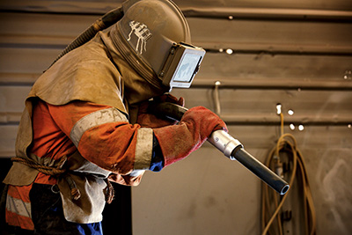

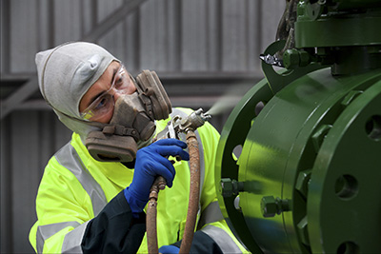
Caption: Compressed air is used extensively at Katere Coatings in both abrasive blasting and painting

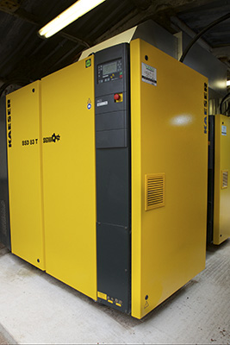
Caption: A Kaeser ASD 50 T and a BSD 83 T rotary screw compressor, both with integrated refrigeration dryers installed at Katere Coatings

