Impressive power and efficiency from Kaeser
Introducing the new space-saving FSD rotary screw compressors
Kaeser Compressors has just announced the launch of its latest generation FSD series rotary screw compressors. The new space-saving models house a number of product refinements and enhancements which together are delivering impressive power and efficiency to the end user.
Air-cooling of rotary screw compressors can be significantly more cost effective than water-cooling and this advantage is now made available for larger drive powers over 250 kW with Kaeser’s new FSD series of rotary screw compressors. The radial fan in Kaeser’s highly effective cooling system draws in ambient air directly through the cooler without being pre-warmed to ensure optimum cooling performance. FSD compressors can therefore be used in ambient temperatures as high as + 45 °C. All FSD models are also optionally available as water-cooled versions.
In every model, the thermostat-controlled radial fan for fluid cooling helps achieve further energy savings. It is integrated into Kaeser’s Electronic Thermo Management (ETM) system, which is another significant innovation in the new FSD series:
ETM regulates oil temperature to ensure a safe and consistent differential from the dew point temperature, thereby avoiding unnecessarily high compressed air discharge temperatures and leading to additional energy savings. With the heat recovery option, a second ETM system assures optimised and even more efficient usage of the available heat energy.
This optimised efficiency results from the newly refined screw compressor blocks equipped with high efficiency and flow optimised Sigma Profile rotors. Developed by Kaeser and continuously enhanced ever since, the Kaeser Sigma Profile achieves power savings of up to 15 percent compared with conventional screw compressor block rotor profiles. Furthermore, the screw compressor block is directly driven by an energy-saving IE4 super premium efficiency motor that operates at a low speed of 1490 rpm. Direct drive not only eliminates the transmission losses associated with gear drive, but also reduces energy consumption, maintenance requirement and sounds levels.
The unit interior also reflects Kaeser’s commitment to resource conservation: the environmentally friendly fluid filter cartridges no longer have a permanently attached sheet metal housing, but rather are simply inserted into an aluminium housing. The filter cartridges themselves feature a metal-free design and are suitable for thermal disposal at the end of their service life without additional pre-treatment.
As with all other Kaeser compressors, the new FSD series rotary screw compressors are service friendly, with excellent accessibility to all maintenance components resulting in ease of maintenance, reduced operating costs and increased availability.
The user-friendly Sigma Control 2 compressor controller provides additional energy savings, reduced maintenance requirement, as well as improved operational reliability and compressor availability by dynamically adjusting the flow rate to match actual compressed air demand.
The large display makes it easy to view key information. Including RFID technology assures safety of data and login, meaning service work and system changes to the compressor can only be performed by authorised personnel.
Energy saving control modes, variable communication interfaces for communication with centralised control systems, and an SD card for update and backup are just some of the many features available on the Sigma Control 2.
In addition, the Sigma Control 2 communicates seamlessly with the Sigma Air Manager 4.0 master controller and management system from Kaeser Compressors, which also features adaptive 3-D Control. Depending on the version, this powerful controller can simultaneously monitor and co-ordinate operation of up to 16 compressors and treatment components with optimum efficiency.
The FSD.3 series rotary screw compressors are available air- or water- cooled, with drive power 250 & 315 kW, working pressures 7 to 15 bar and free air deliveries from 29.2 to 58 m³/min. They are available as a standard machine fixed speed machine or with Sigma Frequency Control.

File: A-FSD_3-aus
Approved for publication, copy acknowledgement appreciated

Image:
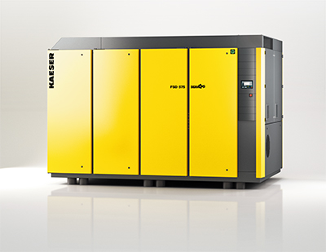

Impressive power and efficiency with the space-saving Kaeser FSD rotary screw compressor

