Exceptional efficiency and dependability from Kaeser
Compact, quiet, energy efficient and ready to connect, the BBC and FBC series of rotary blowers from Kaeser are ideal wherever a supply of low pressure compressed air is required.
The BBC and FBC series of rotary blowers from Kaeser have been designed to incur minimal operating and maintenance costs and to ensure maximum reliability. Ideal for applications such as conveying and water treatment, these compact blowers come ‘ready-to-connect’. This means that the units are supplied complete with all sensors, controls and a choice of star-delta starter or variable speed drive.
The complete system packages are CE and EMC certified. The machines and the electrics are preconfigured and ready-adjusted at the factory, creating less work for both the operator and system provider when it comes to planning, installation, certification, documentation and commissioning.
The BBC and FBC series blowers from Kaeser are extremely quiet in operation thanks to highly effective broadband sound and pulsation damping which applies to both the machine and the pipework.
Operational reliability and uptime is signifcantly enhanced due to the inclusion of a blower block with proven Omega profile rotors, whilst adaptive compression reduces energy consumption, and long bearing life minimises maintenance costs.
A space-saving component layout results in an exceptionally compact footprint. Components such as control valves and exhaust silencers, which would normally be installed external, are integrated. In addition, these blowers have been designed to allow all service work to be carried out from the front of the unit. With the star-delta equipped models, this makes it possible to install several blowers side by side.
All blowers in this range come with an internal Sigma Control 2 controller. Blower mode selection, such as remote speed control or pressure control, is therefore made quick and easy - all at just the press of a button.
Performance parameters relevant for dependable blower performance are monitored by sensors, and warning or fault signals are automatically generated accordingly. Optional communication via databus (multiple databus systems can be connected) allows operational status read out and enables the machine to be remotely controlled.
Highly efficient and energy saving, the rotary blower range from Kaeser covers air deliveries from 2 to 72 m³/min at up to 1000 mbar gauge pressure and 500 mbar vacuum.

File: h-bbc-aus
Approved for publication, copy acknowledgement appreciated
Image:

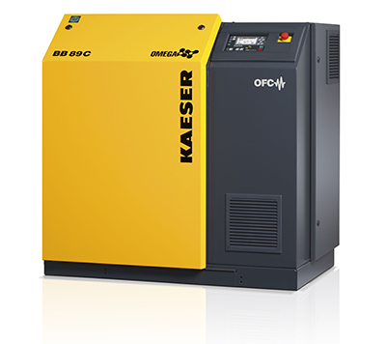
Kaeser’s BBC/FBC rotary blowers combine clever design with exceptional efficiency and dependability

