Kaeser blower system assists Collie WWTP in meeting diurnal process aeration requirements
Three Kaeser EBC series blower systems were recently installed at Water Corporation's Collie Wastewater Treatment Plant (WWTP) to efficiently and reliably meet the compressed air requirements of an upgraded process aeration system.
Water Corporation supplies water, wastewater and drainage services to thousands of homes and businesses in Western Australia. Wastewater management is an essential part of the water cycle and at present, the Water Corporation is responsible for the collection, treatment and either reuse or disposal of almost 450 million litres of wastewater a day!
When the wastewater reaches one of the many treatment plants (WWTP) that Water Corporation operates, it must go through a number of processes before it can be returned to the environment. From aeration to digestion, a reliable and high quality supply of compressed air is required.
Recently, an inadequate process aeration system at the Collie WWTP was upgraded by the Water Corporation. With a Kaeser blower system already reliably powering the digestion process at the Collie WWTP, the local authorised Kaeser Partner, Pneumatic Engineering was requested to propose a suitable blower system upgrade solution for the aeration process.
To efficiently meet the demand for compressed air, Pneumatic Engineering recommended and subsequently supplied three Kaeser Compact EBC series blower systems.
Part of the Compact series from Kaeser, the EBC models have been designed to incur minimal operating and maintenance costs and to ensure maximum reliability;
Every Kaeser blower is equipped with a high efficiency blower block featuring Omega Profile rotors and an IE3 electric motor (which complies with and exceeds prevailing Australian GEMS regulations for 3 phase electric motors) to ensure maximum energy savings and outstanding system performance. These highly reliable and robust Omega Blower blocks feature long life roller bearings and come pre-lubricated, ready for use.
In addition, a clever design not only delivers exceptional efficiency and dependability but also ensures a small footprint and ease of maintenance. An access friendly configuration enables side-by-side installation of multiple units, whilst a space saving component layout results in a very compact footprint.
The Kaeser Compact series blower units are further delivered complete with an acoustic enclosure which has been designed to minimise noise emissions.
The Water Corporation commented; 'The blower systems have been up and running for over 12 months. In that time they have proven to be exceptionally quiet in operation and very reliable in efficiently delivering compressed air as and when required.'
Together with their minimal maintenance and service requirements, these versatile blowers ensure lowest life cycle costs. Mechanically tested in Germany, the Kaeser BB-FB series rotary blower packages, are available with free air deliveries from 1.5 to 74 m³/min, pressure up to 1000 mbar, and vacuum to 500 mbar.

File: Q-Collie-aus
Approved for publication, copy acknowledgement appreciated
Images: (contact the press office for high res copies of the following images)

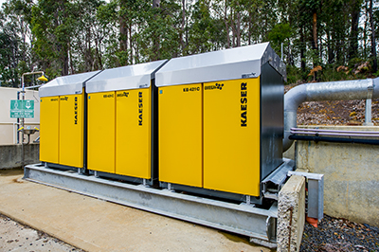
Caption: Three Kaeser Compact EBC series blower systems are being used for aeration at the Collie WWTP
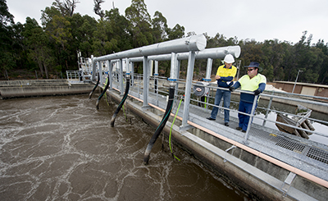
Caption: From aeration to digestion, a reliable and high quality supply of compressed air is required

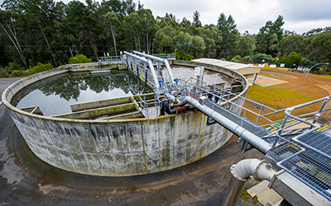
Caption: Water Corporation is responsible for the collection, treatment and either the reuse or disposal of almost 450 million litres of wastewater a day! (pictured the Collie WWTP)

