An oldie but a goodie: Kaeser compressor stands the test of time at KBW
A Kaeser Airtower 11 rotary screw compressor with integrated refrigeration dryer is continuing to supply leading vehicle repair company Koudsy Body Works with a reliable, high quality, clean and dry supply of compressed air after more than a decade of service.
Based in Artarmon, New South Wales, Koudsy Body Works (KBW) is a family owned and managed business with over 30 years of experience in the vehicle repair industry. KBW caters for both vehicle repair insurance and private work as well as specialising in car and motorcycle custom and restoration work.
Dedicated to completing work at the highest standards, KBW constantly keeps its team trained in an evolving industry as well as choosing to invest in state-of-the-art machinery to ensure that each motor vehicle that leaves the shop looks better than it ever has.
From powering air tools to the spray paint booth, compressed air is an integral part of the operation. Just over a decade ago, an ageing compressed air system prompted Charles Koudsy, the Manager at KBW to contact their long standing compressed air partner - Fracks - for a solution.
After reviewing the compressed air requirements at KBW, Fracks - an authorised Kaeser Partner - recommended and subsequently installed an Airtower 11.
The Airtower from Kaeser was a compact compressor solution that incorporated a rotary screw compressor and refrigeration dryer all within one housing. This series was recently superseded with the SM T series models.
Like the current Kaeser SM T rotary screw compressors with integrated refrigeration dryer, the Airtower 11 was designed and manufactured in Germany to Kaeser’s superior build quality standards.
At the heart of the Airtower 11 lies a premium quality screw compressor block equipped with the Kaeser ‘Sigma Profile’ rotors. Developed by Kaeser and enhanced ever since, the Kaeser Sigma Profile achieves power savings of up to 15 percent compared with conventional screw compressor block rotor profiles.
The Airtower 11 at KBW also features an integral refrigeration dryer. This has kept the space requirement for the system to a minimum whilst ensuring that the compressed air produced is clean and dry – a key criteria of compressed air used for spray painting in the vehicle repair industry.
As with all other Kaeser compressors, the Airtower was designed and built to be maintenance friendly, with excellent component accessibility from one side of the machine.
In operation for over 10 years, Koudsy commented: ‘If our compressor doesn’t work, our business doesn’t work. Especially for the spray painting side of the business, without quality and reliable compressed air we cannot function. The air also needs to always be clean with no moisture in the line. If this were to occur it would jeopardise the quality of the finish and be costly to re-do. We pride ourselves on the quality of work we do and it is essential that we use quality equipment. We have had the Kaeser compressed air system for quite some time now and it continues to work reliably and efficiently for us.’
The current SM T series of rotary screw compressors with integrated refrigeration dryer from Kaeser are available with working pressures 7.5 to 13 bar, motor power 5.5 to 9 kW and free air deliveries 0.56 to 1.50 m³/min.

File: Q-KBW-aus
Approved for publication, copy acknowledgement appreciated
Images: (contact the press office for high res copies of the following images)

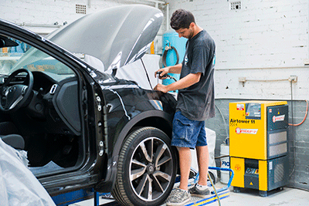

Caption: A Kaeser Airtower 11 is standing the test of time at KBW
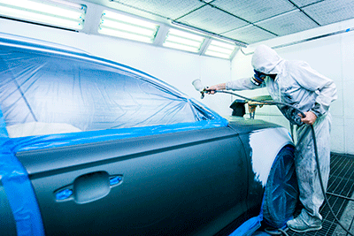
Caption: Compressed air is used extensively at KBW including powering the spray paint booth

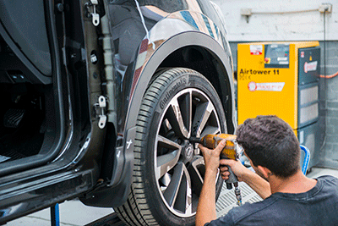
Caption: Compressed air used here to power an air tool at KBW

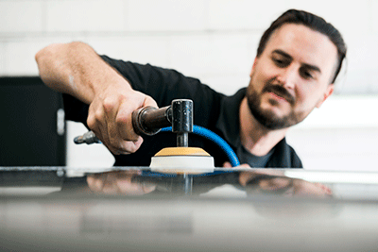
Caption: KBW is a leading vehicle repair company based in NSW

