Kaeser to be panellist at the AMTIL National Conference 2017
Kaeser Compressors is encouraging manufacturers that want to learn more about the benefits of embracing Industrie 4.0 to attend the Australian Manufacturing Technology Institute’s National Conference - ‘Manufacturing’s Future in a Digital Age’.
The one day AMTIL (Australian Manufacturing Technology Institute) National Conference – ‘Manufacturing’s Future in a Digital Age’, will provide manufacturers that attend with the latest information on how the digital world will impact industry in both the short and long term.
The conference includes a number of guest speakers and panel discussions. Mark Dudman, National Sales Manager of Kaeser Compressors Australia Pty Ltd, will be part of one panel of speakers discussing the topic ‘New technology in the production process technology applications’ at the conference.
The way we manufacture is no doubt entering a new era led by the advances, networking and connectivity capabilities of production processes and technology. Coined Industrie 4.0, this new era presents a number of opportunities and benefits to manufacturers that choose to embrace this ‘factory of the future’. As part of the new technology panel discussion at the AMTIL National Conference, Dudman will explain the evolution of Industrie 4.0, how the factory and compressed air system of the future will look and the benefits they both hold.
As a leader in the engineering of compressed air technology, Kaeser products and services are not only designed to deliver the most reliable, efficient and cost-effective compressed air supply possible, but they are also fully ready to take advantage of the future oriented benefits that Industrie 4.0 has to offer. In the ultra-flexible Industrie 4.0 production environment, intelligently networked compressed air systems provide the optimal compressed air power and quality required. Moreover, potential issues within the compressed air network are identified at a very early stage so that appropriate service measures can be taken before a fault event occurs.
The AMTIL National Conference – ‘Manufacturing’s Future in a Digital Age’, takes place on Tuesday 14th November 2017 at the Leonda by the Yarra in Hawthorn, Victoria. Registration with AMTIL is essential.

File: o-AMTIL-conference-2017-aus
Approved for publication, copy acknowledgement appreciated
Image:

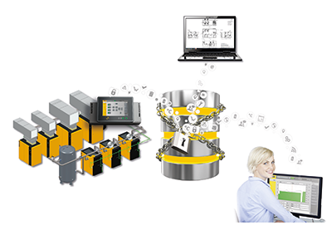
In the Industrie 4.0 production environment, intelligently networked compressed air systems provide the optimal compressed air power and quality required.

