An energy efficient powerhouse
Kaeser launch second generation TE series refrigeration dryers

Kaeser has launched its second generation TE series industrial refrigeration dryers. Part of the renowned Secotec range from Kaeser, the TE.2 series models deliver stable pressure dew point performance, exceptional dependability and low life-cycle costs, all within a compact and energy saving design.
Thanks to the consistent use of high quality components and decades of expertise in system design and engineering, the second generation of these advanced dryers from Kaeser are setting new standards when it comes to energy efficiency.
There are a number of key features which each play an important role in ensuring the outstanding efficiency of these new dryers; the scroll refrigerant compressors used in the TE.2 series dryers are up to 26 percent more efficient than reciprocating compressors, generously dimensioned flow cross-sections within the heat exchanger and compressed air connections ensure an exceptionally low differential pressure and, these dryers also have a very low specific electrical power consumption requiring less than 97 W of electrical power per m³/min of compressed air (ISO 7183 A1).
The TE.2 series refrigeration dryers from Kaeser feature an efficient phase change material which gives the exceptionally compact Secopack LS heat exchanger system its impressive thermal storage capacity. Special heat transfer elements ensure rapid charge and discharge, while premium-quality heat insulation boosts efficiency even further.
The refrigeration dryer includes an innovative Sigma Control Smart electronic controller, which controls the thermal storage process. Refrigeration dryer load constantly fluctuates between 0 and 100 percent. Unlike conventional partial load control systems, Secotec storage control precisely adjusts electrical power consumption during all load phases. This allows Secotec refrigeration dryers to save almost 60 percent of energy costs compared to refrigeration dryers with hot gas bypass control running at an average of 40 percent of capacity.
In contrast to conventional systems, the thermal mass in Secotec dryers always remains cool. This means compressed air can be dried effectively even during start-up phases. The high quality insulation around the thermal mass also helps keep energy usage to a minimum. Compressed air drying with Secotec refrigeration dryers not only ensures exceptional energy efficiency, but also, thanks to their impressive thermal capacity, provides material-friendly operation. In addition, the rapid reaction Secopack LS heat exchanger system ensures stable pressure dew points at all times.
Together with the innovative Secopack LS latent heat storage heat exchanger system and the Sigma Control Smart controller, the next generation of these advanced dryers set new standards when it comes to energy efficiency, compact design and user-friendliness.
Simple to install, easy to maintain and Industry 4.0 ready, the compact TE.2 series refrigeration dryers from Kaeser are available with flow rates 10.5 to 14.1 m³/min and pressures up to 16 bar.

File: d-TE-aus
Approved for publication, copy acknowledgement appreciated
Image:

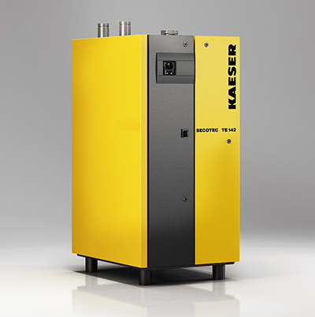
An energy efficient powerhouse from Kaeser Compressors
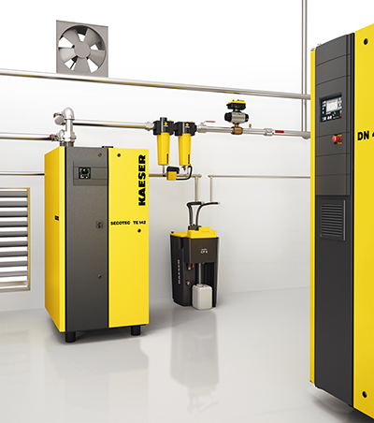
Efficient and reliable compressed air treatment is essential when it comes to economical compressed air production

