Kaeser Compressors supplies Kwinana Power Station with absolutely clean compressed air
Four Kaeser DSG-2 series dry-running rotary screw compressors are supporting one of the world's most efficient simple-cycle gas turbines at the Kwinana Power Station in Western Australia. These state-of-the-art compressors are supplying absolutely clean compressed air which is free of oil, water and dirt contaminants.
Synergy's Kwinana Power Station (KPS), is located 40 kilometres south of Perth and is connected by 66,000 volt, 132,000 volt and 330,000 volt transmission lines to the South West Interconnected System (SWIS). SWIS is the primary electricity grid in Western Australia (WA), supplying the bulk of the South-West region - an area which stretches north to Kalbarri, south to Albany and east to Kalgoorlie. KPS is unique in WA in that it is capable of burning three fuels - coal, natural gas and oil.
In 2012, UGL was commissioned by Synergy to build two high efficiency gas turbines (HEGTs) on the Kwinana site. These were to be installed to replace two decommissioned 120 MW steam powered generators. Requiring compressed air to aid the operation of the new HEGTs, and having previously worked on several other projects together, UGL called upon Kaeser Compressors Australia.
The production of absolutely clean compressed air was paramount to the project. As a result UGL chose to install four Kaeser DSG-2 series dry-running rotary screw compressors.
As Jeff Coyle, Engineering Manager at Kaeser Compressors Australia said: 'UGL had very explicit clean air requirements for the turbines which the DSG-2 series dry-running screw compressors from Kaeser could meet.'
The proven DSG-2 series dry-running rotary screw compressors from Kaeser produce high quality, oil free and ultra-efficient compressed air at all times. At the heart of every compressor is a tried and tested dry-running, two-stage rotary screw airend. Providing optimum performance and dependability, every airend ensures maximum efficiency throughout its entire service life.
Two Kaeser compressed air stations were subsequently installed next to each of the HEGTs. Each station consists of two Kaeser DSG 220-2 dry-running rotary screw compressors, two desiccant dryers, a 13000L capacity air receiver, a Sigma Air Manager and carbon filters. Matthew Weston, Site Manager at Synergy's Kwinana Power Station said: 'Their key task is to keep the turbines bearings in position...during operation and cool-down. We also use low pressure clean air for insulation purposes during isolated phase bus operations.'
Even with Western Australia's arid climate, these compressors are able to run smoothly at ambient temperatures of 45ºC or higher. One compressor in each station is on continuous run, whilst the other provides full standby cover. The machines are rotated regularly to maximise life cycle and efficiency of the station.
Coyle concluded: 'The compressors [when maintained properly] will meet or exceed the life of the HEGTs. They will continue to proficiently support the state-of-the-art HEGTs that generate such an important energy source throughout Western Australia.'
Powerful, durable and efficient, the Kaeser DSG-2 series dry-running screw compressors feature water- or air- cooling as required with drive powers up to 355 kW and free air deliveries from 13.5 up to 50 m³/min (fixed speed) or 6.8 to 51.8 m³/min (frequency controlled).

File: Q-Kwinana-aus
Approved for publication, copy acknowledgement appreciated
Images: (contact the press office for high res copies of the following images)

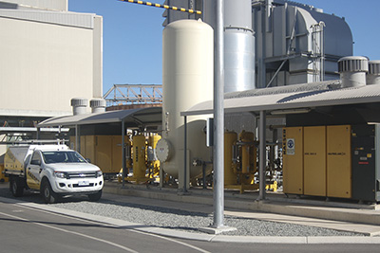
Caption: Four Kaeser DSG-2 series dry-running rotary screw compressors are supplying absolutely clean compressed air to the Kwinana Power Station in WA.

