Kaeser to present its quiet, compact and highly efficient range of oil free medical compressors at IHEA 2017

Kaeser Compressors will present its quiet, compact and highly efficient range of oil free turnkey medical compressed air solutions at the IHEA Healthcare Facilities Management Conference 2017.
Producing absolutely clean compressed air is essential in the medical sector. Kaeser has a number of solutions to help meet this requirement, such as its compact and highly efficient Airbox dry-running reciprocating medical compressor packages.
At the heart of each unit lies a dry-running, directly coupled reciprocating compressor from Kaeser's renowned KCT range, constructed to the highest quality standards that combines both impressive performance and energy efficiency. A clever air flow design further ensures optimal system cooling which, unusually for a reciprocating compressor, allows up to 100 percent duty cycles and dependable operation in high ambient temperatures.
Quiet in operation, the Airbox units emit only ultra-low sound levels of between 58 to 66 dB(A).
The Airbox units from Kaeser also include an electronic Sigma Control Basic control system. The Sigma Control Basic LED screen on these units, allows quick and simple operation with clear icons and large display. Amongst a number of functions, the display highlights when a service is due, for optimum compressor system efficiency and reliability. These quiet and compact turnkey compressor solutions combine exceptional efficiency, ease of maintenance, durability and perfectly matched components to ensure years of dependable performance with minimal total system costs. Easy to operate and user-friendly, providing users with exceptional flexibility, the Airbox units are available with five different motor powers from 2.4 to 7.5 kW, and with compressed air deliveries from 0.28 to 0.95 m³/min.
Industrie 4.0-ready, KAESER delivers a wide range of oil free compressor solutions to the medical sector that can be seamlessly incorporated into a production and energy management system.
Discover your industrie 4.0-ready oil free compressor solution with Kaeser Compressors. Find us from 11 to 13 October at the IHEA Healthcare Facilities Management Conference 2017, being held at the Pullman Melbourne Albert Park.

File: o-IHEA-aus
Approved for publication, copy acknowledgement appreciated
Image:

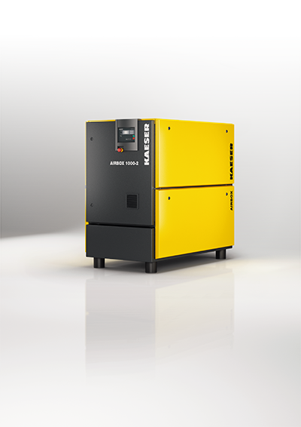
The compact Airbox oil free medical compressor packages keeps space requirements to a minimum.

